SHENZHEN EXC-LED TECHNOLOGY CO.,LTD
Shenzhen EXC-LED Technology Co., Ltd. (Hereinafter referred to as EXC-LED; brand: EXC), a national high-tech enterprise integrating LED application product design, R&D, production, sale and service, has always been focused on LED outdoor landscape lighting and cloud control system, a committing itself to provide stable and reliable comprehensive smart lighting system solutions for customers all over the world.
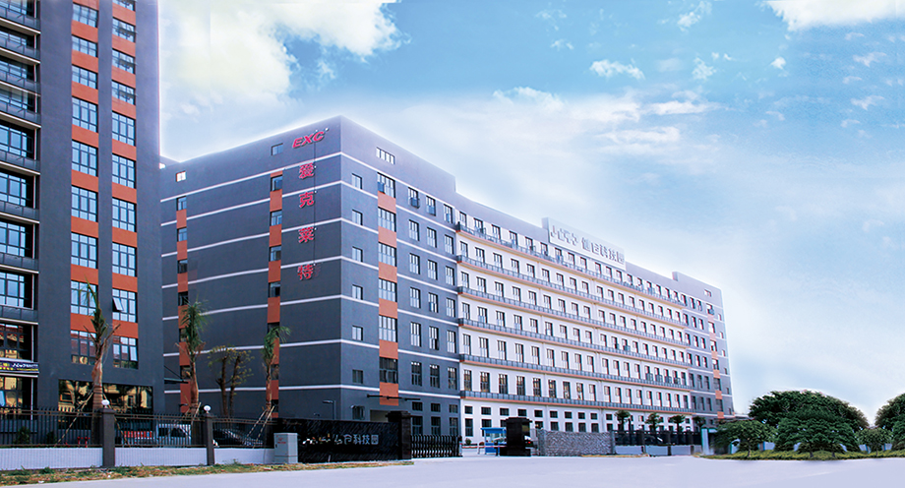
Relying on the industry-leading innovative technologies as well as the advantage of stable and reliable quality, the Company has now become the major supplier of outdoor lighting centralized control systems and products for the 7th CISM Military World Games in Wuhan, the major supplier of themed lighting control systems and products for the SCO Summit in Qingdao, the major supplier of themed lighting products for the BRICS Summit in Xiamen, the major supplier of themed lighting control systems and products for the G20 Summit in Hangzhou, and the major supplier of lighting control systems and products for the 40th Anniversary Celebrations of Shenzhen Reform and Opening-up; furthermore, it is also the major supplier of lighting control systems and products for overall lighting projects in large cities such as Nanchang, Haikou, Fuzhou, Beijing, Shanghai, Guangzhou, Changsha, Nanjing, Chongqing, and Urumqi.
Our Products: LED Pixel Light LED Linear Light LED Wall Washer Light LED Flood Light
Contact us:sales@exc-led.com
https://www.exc-light.com/

