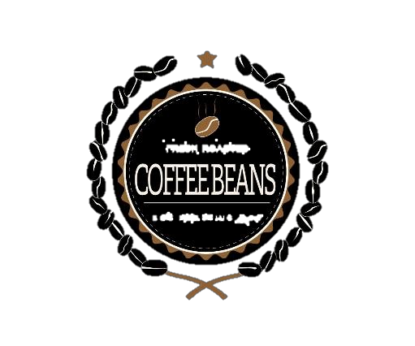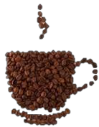
PREMIUM QUALITY
STRONG DEVIL COFFEE
NET WT
9 oz / 250g
DEVIL STRONG
THE PODOCARPUS SP. IT IS A TREE SPECIES THAT GIVES SHADOW TO COFFEE. THE NATIVES CALL IT DIABLO FUERTE BECAUSE WHEN THIS DRY CAN NOT BE NAILED OR A NAIL. COFFEE IS PRODUCED IN THE CUSTODY AREA OF YANACHAGA CHEMILLEN NATIONAL PARK, WHERE HUNTING, FISHING AND EXCESSIVE USE OF CHEMICAL PRODUCTS IS PROHIBITED, THE PARK IS THE SOURCE OF WATER FOR OXAPAMPA AND WILD ANIMALS IN DANGER OF EXTINCTION.

MANUFACTORY BY STRONG DEVIL COFFEE
BLACK ROASTED
Km. 18.5 HIGHWAY MARGINAL
– HUANCABAMBA OXAPAMPA – PERU TELEPHONE: +51 - 956770433
R.U.C 20600829981
LOTE: 12598 F.V. 30/05/2020


PREMIUM QUALITY
STRONG DEVIL COFFEE
NET WT
9 oz / 250g

DEVIL STRONG
THE PODOCARPUS SP. IT IS A TREE SPECIES THAT GIVES SHADOW TO COFFEE. THE NATIVES CALL IT DIABLO FUERTE BECAUSE WHEN THIS DRY CAN NOT BE NAILED OR A NAIL. COFFEE IS PRODUCED IN THE CUSTODY AREA OF YANACHAGA CHEMILLEN NATIONAL PARK, WHERE HUNTING, FISHING AND EXCESSIVE USE OF CHEMICAL PRODUCTS IS PROHIBITED, THE PARK IS THE SOURCE OF WATER FOR OXAPAMPA AND WILD ANIMALS IN DANGER OF EXTINCTION.

MANUF BY STRONG DEVIL COFFEE
Km. 18.5 HIGHWAY MARGINAL
– HUANCABAMBA OXAPAMPA – PERU TELEPHONE: +51 - 956770433
R.U.C 20600829981
LOTE: 12598 F.V. 30/05/2020

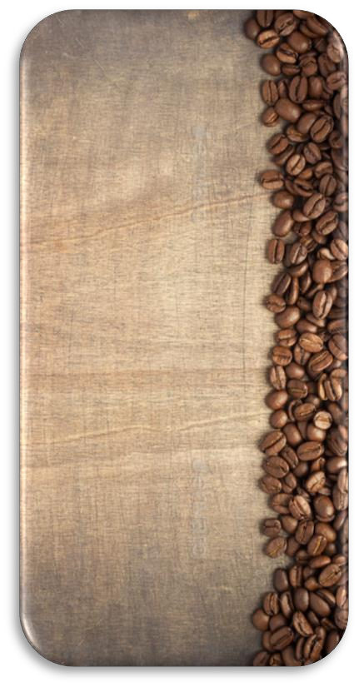
NET WT
9 oz / 250g

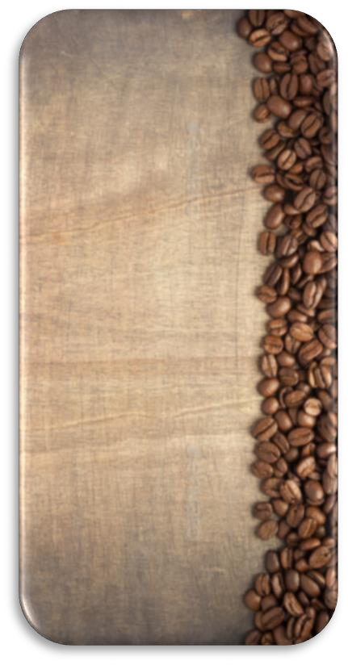
THE PODOCARPUS SP. IT IS A TREE SPECIES THAT GIVES SHADOW TO COFFEE. THE NATIVES CALL IT DIABLO FUERTE BECAUSE WHEN THIS DRY CAN NOT BE NAILED OR A NAIL. COFFEE IS PRODUCED IN THE CUSTODY AREA OF YANACHAGA CHEMILLEN NATIONAL PARK, WHERE HUNTING, FISHING AND EXCESSIVE USE OF CHEMICAL PRODUCTS IS PROHIBITED, THE PARK IS THE SOURCE OF WATER FOR OXAPAMPA AND WILD ANIMALS IN DANGER OF EXTINCTION.
Km. 18.5 HIGHWAY MARGINAL
– HUANCABAMBA OXAPAMPA – PERU TELEPHONE: +51 - 956770433
R.U.C 20600829981
LOTE: 12598 F.V. 30/05/2020

