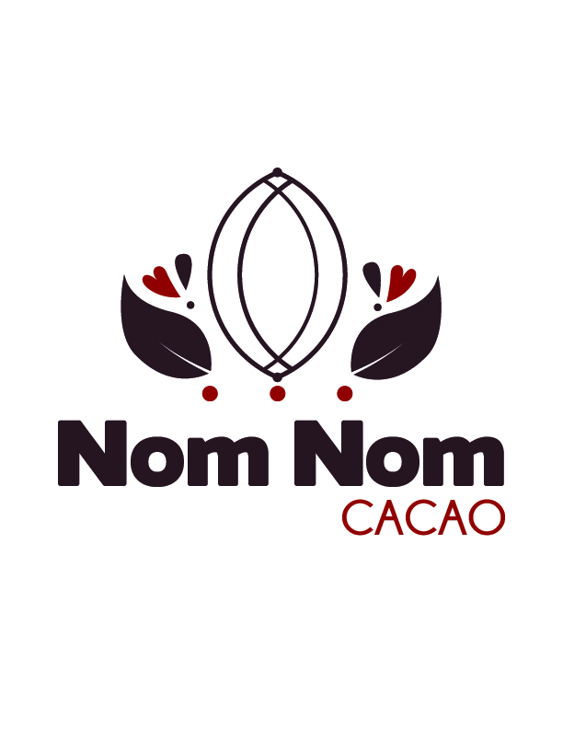

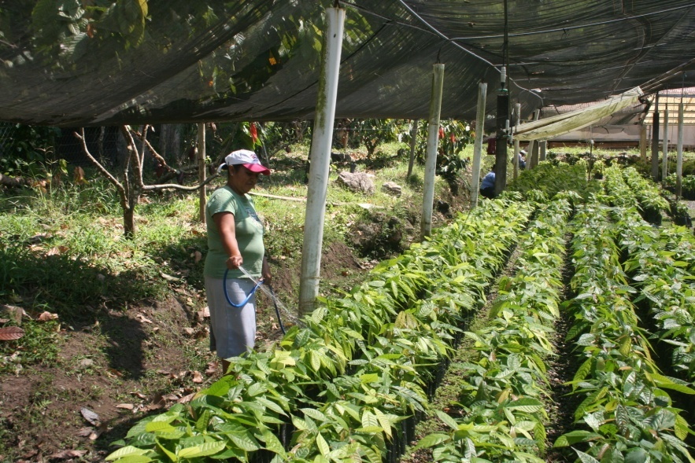

**The best in the world!**

**Honduras high-grade chocolate and coffee!**

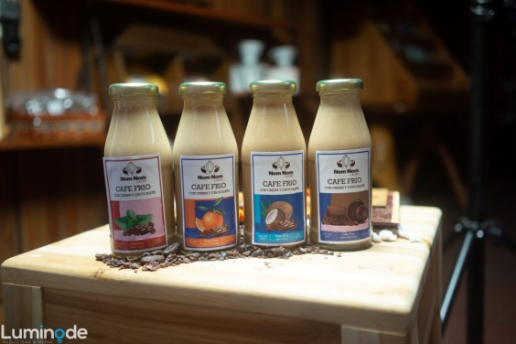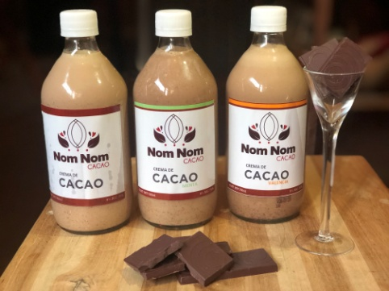

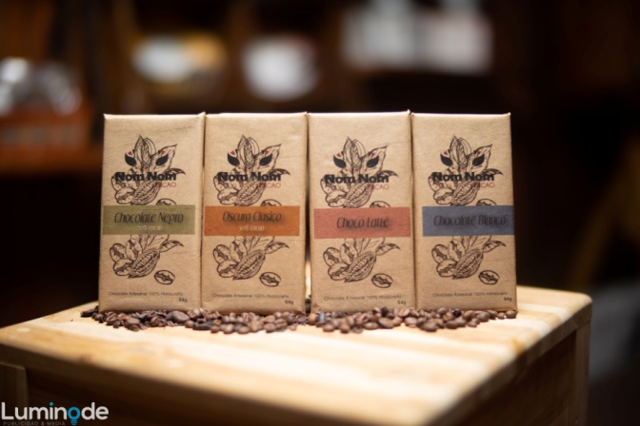

Find us at:

Tabacos y Café

Barrio Guamilito 9 ave. y 6 calle

N.O. San Pedro Sula,

Cortés, Honduras

Cel: (504) 8984-9920

www.nomnomcacao.com

Fb: @nomnomcacao

Instagram: @nomnomcacao

Nom Nom Cacao produces

and sells cacao and coffee

derived products 100% harvested in Honduran fertile soils.

Honduras cacao is ranked among the

top 5% fine cacao in the world and it´s the 5th largest exporter of coffee globally.

Nom Nom Cacao was selected among 243 small businesses in Honduras for the quality and taste of our goods.

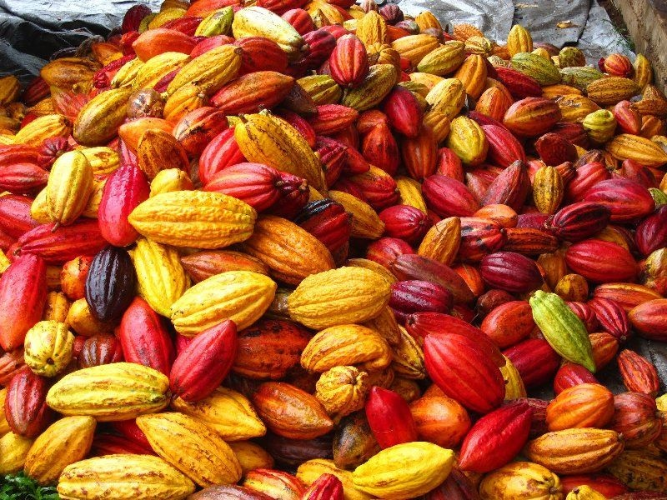

Please allow us to present our 3 top selling products:

Cacao Rum Cream

* Ancestral Mayan cacao, rum and fresh cream blend together to create an exquisite chocolate liquor.
* Savour this chocolate-cream base liquor in 3 different flavors:

Chocolate, Mint and Valencia.

**Just when you thought it could not get any better…**

Cold brew chocolate cream coffee

* Our balanced, sweet, and fruity flavored coffee in perfect harmony with the chocolate liquor will delight your taste.
* Available in Coconut, Valencia, mint and Original.

Dark Chocolate bars

* High quality 100% Honduran
* Selected cacao beans
* Artisan chocolate, no additives
* 70%, 50%, Milk and White chocolate bars