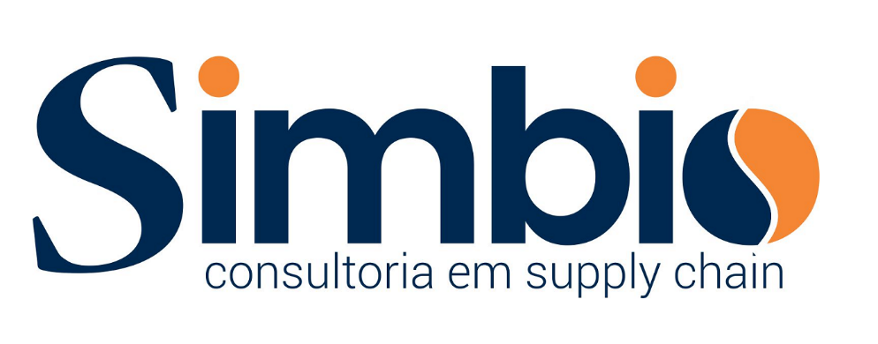

*"We cannot solve our problems with the same thinking we used when we created them"- Albert Einstein*

*Experts in Latin America Supply Chain Solutions are bringing their core competencies to help customers to grow their business. Translating Global Supply Chain into Brazil or Latam E2E Business Environment & Local Content required plus an out of box point of view on how to do business will take a new approach for our customers and bring competitive advantages for their organizations.*

*Joining forces with our local Partners will make our Supply Chain solutions perfect for any customer who wants to make business in Latin America. Our team have broad experienced people who can support all types of business improving their processes and controls.*

Tasks:

* + Business Inteligence
  + Plan ahead
  + Priorities
  + Process
  + Track & Trace

Customer needs:

* + Clear Objectives
  + Cost Targets
  + Resources
  + Timebound
  + Competitive factors

Results:

* + Measurement
  + Sucess
  + Control

# *Mission*

*Help and support Customers to achieve their goals and accomplish projects enabling the best class supply chain bringing customized solutions with highest ethical principles! Be innovative, be efficient, and be proud to work with SIMBIO increasing competitiveness for our customers.*

# *Vision*

*To be the best Supply Chain Solution Provider for our customers based on our partners experience looking to delight our customers.*

# *Values*

*Customer Experience, Ethical, Integrity, Passion, Innovation, Team work, Partnership, Win-Win Culture*

*“SIMBIO Consulting has professionals more than 20 years of Supply Chain experience in Latin America and Brazil. Deep knowledge on all Commercial aspects of Supply on Tax & Regulatory Compliance, Cost enablers used to deploy business on this region. “*

*“Supply Chain Solutions tailored for your business driving excellent results for processes like International Trade, Compliance, Logistics, Procurement, Sourcing, PMO, Tax Incentives based on products or customer needs.”*

# *Efficient Supply process = Better Profit*

**Cost Reduction**

Logistics

Tax alternatives

TCO, Spend Analysis

Purchasing

**LATAM Trade**

Enable Customer products

Search for the best price (profit)

Pursue best cost x operations

**Sourcing**

Local & International Sourcing

NPI, TTM, TTV

Business Inteligence

*Sócios:*

**Supply Chain**

Operations

S&OP

Fulfillment

Logistics

**Product/Services**

Comercial enablement

Sales

Distribution

Local Production

**Profit**

Product Benchmark x Best Price

Tax Alternatives

Legal Alternatives

Sócios:

**Cost Reduction Process**

* Spend Analysis & Optimization, TCO
* AP Transformation
* Purchasing Process validation
  + Supply Analysis (CTO, BTP, BTO, others)
  + Supplier Contract Analysis
    - * Contract Audit
      * BID/offers
  + PMO
    - Buy/Sell processes
    - VMI
    - CM’ing/3rd party production
    - Logistics
    - Tax benefits/protection

**Supplier/Customer Development**

* Supply Chain design
* Local & International Sourcing
* Global Sourcing / Benchmark
* QBR/Quality reports
* ODM/CM development;

**International Trade**

* Import/Exports from/to Latin America and Brazil
* Enable Foreign Commerce to Latam & Brazil
* Exports from Brazil
* International Partnership/Local Sales Expertize
* Customs & Compliance Expertize
* IPO

**Supply Chain Management**

* Operations
* Design Process & Enablement
* S&OP
* Organizations (design & Mgt)
* Supply & Purchasing Mgt
* CTO, BTO, BTP, etc management
* Local Supply management
* Local compliance management

**Local Incentives:**

* Tax analysis
* Corporate Affairs
* Local Investment, Procure by Tax Incentives
* Government and National Associations interlock
* Regional Policy Strategy development

**Sales Officer**

* Global Alliances & Partnership
* Enabling Supply Operations in Latin America & Brazil

Partners:

* **MERCADO ELETRONICO**

[www.me.com.br](http://www.me.com.br/)

## 

“Established in 1994, we provide e-commerce solutions that combine specialized technologies and services to your Procurement and Logistics departments.

With world-class technological platforms that are well known for their strength and flexibility, we help companies of all sizes in multiple segments do business in a structured way. Our solutions provide our clients with significant cost reduction, increased operational effectiveness, and transparent business transactions.

Our service offering is supported by a database containing thousands of daily business transactions and operational services to streamline your Procurement department. Our strategic services, for instance, incorporate the methodology and intelligence of organizations to improve business performance and rate business partners.”

* **COSTDRIVER / DATAMARK**

<http://www.costdrivers.com/CostDrivers/>

# “Market Intelligence

The COSTDRIVERS® platform was created in 2003 to meet a requirement from NESTLÉ®. It was developed for purchasing and sales departments in order to reduce costs. As a Business Intelligence platform we monitor price and indexes changes, making forecasts of commodities and industrial inputs for more than 15 countries. We also have an updated newsletter from a variety of markets.”

Partners:

**ERVINO SCHNARNDORF** – Supply Chain & Procurement Executive:



Executive level professional with 20+ years of domestic & global experience   
developing strategic, optimized logistics operations for global and high-growth companies.

Business-minded Supply Chain and Procurement Executive with repeated success directing sizeable, cross-functional resources in supply chain, procurement, operations, exports and special projects to full optimization. Develop global business solutions driving record-setting revenues and reducing operational costs. Build consensus across multiple organizational levels and diverse cultural environments. Easily translate big-picture into scalable action programs. Multi global assignments in Latin America, South Africa, Europe, US and China.

Core competencies include:

|  |  |
| --- | --- |
| Supply Chain Management  Procurement Processes  Operational Start-Ups  Cost Reduction and Avoidance  Process Design | Global Markets  Continuous Improvement  Strategic Planning  Budget Accountability  Contract Negotiations |

Contacts:

Cell: +55 51 991275816 (WhatsApp & Wechat)

Email: ervino@simbioconsultoria.com.br

**RICARDO BANDARRA** – Procurement Executive



15 years professional experience in Global Supply Chain areas (sourcing, procurement, etc.), Operations, Start-ups, Logistics, Demand Supply & Forecasting, Project Management, Incentive Management (PPB) at Local and multinational companies developing and managing strategic relationships with suppliers of materials, equipment, production services and indirect.

12 years of experience with National and International Project Management involving companies such as Volkswagen, Petrobras, Usiminas, Seara, DANA, COPESUL, BRASTEMP

International ​​Supply Chain projects in countries such as Argentina, Panama, Germany, China, Singapore, Taiwan, South Korea and the US.

DMAIC tools, S & OP certified Green Belt and SMAC Experience managing multidisciplinary teams.

Extensive experience as ISO9001 auditor and Supply Policies implementation

Contacts:

Cell: +55 51 992302020 (WhatsApp)

Email: bandarra@simbioconsultoria.com.br