**SERVICE IMPORT CUSTOMS CLEARANCE DAN UNDERNAME**

**Subject**  : Offer Of Import Services To Indonesian

**To**  : Dept. Import/Purchasing

**Attacchments** : 3 sheets  
  
TO The Honorable Sir/Madam,

Below We Offer Cooperation In The Field Of Customs Service Management (PPJK) And Domestic Shipping With The Following Price List :

|  |  |  |  |  |  |  |  |
| --- | --- | --- | --- | --- | --- | --- | --- |
| **CUSTOMS CLEARANCE AIR** | | | | **CUSTOMS CLEARANCE PORT LCL** | | | |
| DETAILS |  | COST | Working  Time | DETAILS |  | COST | Working  Time |
| Handling / 200Kgs | Rp. 1.500.000 | | 3-5 Day | Handling / 1000Kgs | Rp. 1.500.000 | | 3-6 Day |
| Handling / Kgs Next | Rp. 601.000 | | Handling / Kgs Next | Rp. 601.000 | |
| Transportasi DKI Jakarta Area | Rp. 600.000 | | Transportasi DKI Jakarta Area | Rp. 600.000 | |
| Rushandling | Rp. 250.000 | | Rushandling | Rp. 250.000 | |
| Bahandle | Rp. 500.000 | | Bahandle | Rp. 600.000 | |
| Edi Transfer ( PIB ) / Doc | Rp. 150.000 | | Edi Transfer ( PIB ) / Doc | Rp. 150.000 | |
| Administrasi | Rp. 100.000 | | Administrasi | Rp. 100.000 | |

|  |  |  |  |  |  |  |  |
| --- | --- | --- | --- | --- | --- | --- | --- |
| **CUSTOMS CLEARANCE CONTAINER 20 FEET** | | | | **CUSTOMS CLEARANCE CONTAINER 40 FEET** | | | |
| DETAILS |  | COST | Working  Time | DETAILS |  | COST | Working  Time |
| Handling Container | Rp. 2.000.000 | | 3-7 Day | Handling Container | Rp. 3.000.000 | | 3-7 Day |
| Handling/Cont Next | Rp. 350.000 | | Handling/Cont Next | Rp. 400.000 | |
| Transportasi DKI Jakarta Area | Rp. 2.500.000 | | Transportasi DKI Jakarta Area | Rp. 3.500.000 | |
| Rushandling | Rp. 250.000 | | Rushandling | Rp. 250.000 | |
| Bahandle | Rp. 800.000 | | Bahandle | Rp. 950.000 | |
| Edi Transfer ( PIB ) / Doc | Rp. 150.000 | | Edi Transfer ( PIB ) / Doc | Rp. 150.000 | |
| Administrasi | Rp. 100.000 | | Administrasi | Rp. 100.000 | |

Description :

Delivery Order Fees For Wherehouse Rental/Storage and Transfers Based on Receipt From Related Parties.

Notes :

Undername Rental Fee :1. LCL Rp.1.500.000 2.Container 20” Rp.2.500.000 3.Container 40” Rp.3.500.000

PRICE IMPORT DOOR TO DOOR SERVICES

**FROM COUNTRY OF ORIGIN TO INDONESIAN**

|  |  |  |  |  |  |
| --- | --- | --- | --- | --- | --- |
| **COUNTRY** | **FREIGHT** | **PRICE** | | **MIN** | **ESTIMATE** |
|  | AIR EXPRESS | IDR. | 200.000 | 10 KG | 3 DAY |
| SINGAPORE | REGULER | Rp. | 150.000 | 10 KG | 7 DAY |
|  | SEA FRIGHT | Rp. | 12.000.000 | 1 M3 | 3 WEEK |
|  |  |  |  |  |  |
|  | AIR EXPRESS | Rp. | 290.000 | 10 KG | 7 DAY |
| KOREA | REGULER | Rp. | 250.000 | 10 KG | 14 DAY |
|  | SEA FRIGHT | Rp. | 19.000.000 | 1 M3 | 35 DAY |
|  |  |  |  |  |  |
|  | AIR EXPRESS | Rp. | 250.000 | 10 KG | 14 DAY |
| MALAYSIA | AIR FREIGHT | Rp. | 190.000 | 50 KG | 14 DAY |
|  | SEA FREIGHT | Rp. | 16.000.000 | 1 M3 | 30 DAY |
|  |  |  |  |  |  |
|  | AIR FREIGHT | Rp. | 190.000 | 50 KG | 14 DAY |
| BANGKOK | SEA FREIGHT | Rp. | 16.000.000 | 1 M3 | 45 DAY |
|  |  |  |  |  |  |
|  |  |  |  |  |  |
|  | AIR FREIGHT | Rp. | 310.000 | 50 KG | 14 DAY |
| VIETNAM | SEA FREIGHT | Rp. | 20.000.000 | 1 M3 | 35 DAY |
|  |  |  |  |  |  |
|  |  |  |  |  |  |
|  | AIR FREIGHT | Rp. | 450.000 | 50 KG | 7 DAY |
| AUSTRALIA | REGULER | Rp. | 350.000 | 50 KG | 12 DAY |
|  |  |  |  |  |  |
|  |  |  |  |  |  |
|  | AIR FREIGHT | Rp. | 350.000 | 50 KG | 15 DAY |
| USA | SEA FREIGHT | RP. | 24.000.000 | 3 M3 | 60 DAY |
|  |  |  |  |  |  |
|  |  |  |  |  |  |
|  | AIR EXPRESS | Rp. | 320.000 | 10 KG | 7 DAT |
| CHINA | REGULER | Rp. | 280.000 | 10 KG | 12 DAY |
|  | SEA FREIGHT | Rp. | 7.000.000 | 0,5 M3 | 30 DAY |

That is the offer of Customs clearance, Door to door and Domestics services that we convey for your attention

and we thank you for your good cooperation.

Best Regards,

**PT. AERO GLOBAL INDONESIA**

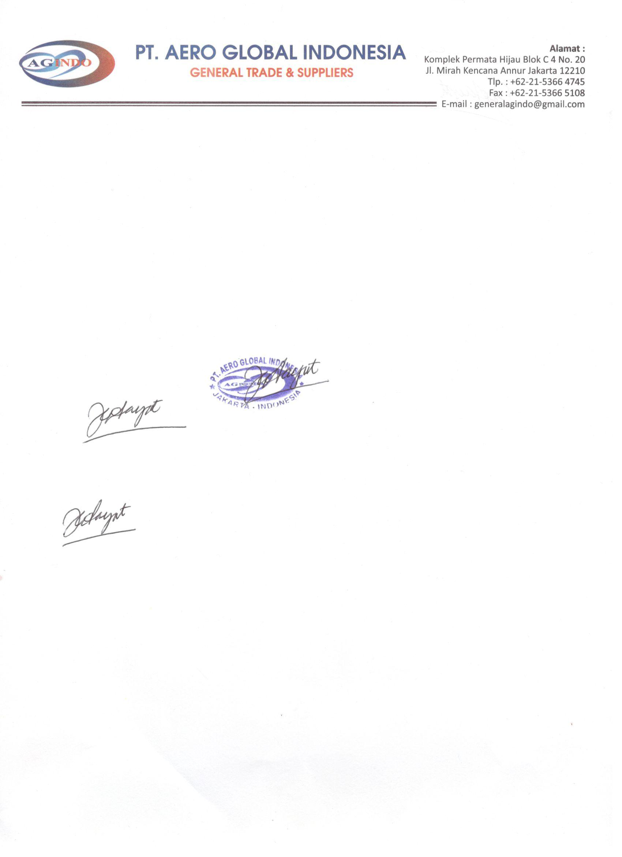 **BAMBANG YUDHIESAN**

**Staff Marketing  
HP/WA** **:** +6282215087272

***Email******:*** *by.aglindonesia@gmail.com*