COMPANY PROFILE



COMPANY INFORMATION

Enterprise Name : Ram Thomas General Trading (pty)Ltd

Enterprise Number : 2018/582547/07

Registration Date : 2018/11/09

Physical address Postal address

612 Tshilamba P O Box 489

Mutale Mutale

0956 0956

CONTACT INFORMATION

Contact number : ( 072 ) 197 8417

Email : [ramudzulip@gmail.com](mailto:ramudzulip@gmail.com)

DIRECTOR

Ramudzuli Phathutshedzo

**1 BRIEF DESCRIPTION OF THE ORGANISATION**

* RAM THOMAS GENERAL TRADING ‘PTY’ LTD is a black owned enterprise

*The business was established in the year 2018 and it was then registered the same year as a private company

*The business main activities are repair s of motor vehicles ,Supply motor vehicles parts , Supply cleaning materials , Supply Protective Clothing ,Supply stationery and general supply

*The business also exists to uplift the living standard of the people in the region , province.

**2 VISION AND MISSION**

The company vision is to recognize as one of the best in Mutale in Rural area in Venda.

The mission of the company is to become the best provider of the motor body repair industry and Ram thomas general trading (pty)Ltd is dedicated to build long term relationships with clients through quality, customer support and great after repair servive.

Our mission is to ensure that we do not lose sight of our vision by provide the best quality services to meet the needs of our clients and customers.

Supply quality goods

**3 BUSINESS STRUCTURE**

As a company we intend to make sure that we start on the right footing by getting the right employees so that the company will grow and make profit.

**4 BBEE STATUS**

Ram thomas general trading(pty)Ltd is proud to announce that is a Level (1) contributor

**5.OWNERSHIP**

Ram thomas general trading (pty)Ltd is a 100% black owned company

**6.SWOT ANALYSIS**

Having a swot analysis is very important as this would help us to know what our chances of succeeding in this market are and how we can improve on our weakness.

**6.1 STRENGTH**

By having excellent customer service that is dedicate to ensure that customers complaints are take care without delays.

6.2 **WEAKNESS**

Afraid of not provide quality services that will impress or that will make our clients or customers to come again and afraid of shortage of funds.

6.3 **OPPORTUNITIES**

To provide the best quality services to our clients and customers and hire more staff.

6.4 **THREATS**

Every business is face with threats so the threats that would face us in thus area is when we compete with the existing company.

**7 OPERATIONAL ACTIVITIES**

We offer the following: ( Maintenance services )

* Repairs motor vehicles
* Penal Beating
* Respray
* Dent repairs
* Car polishing
* Air bag Restoration

SUPPLY

* Supply of protective clothing

* Supply of office machines

* Supply of stationery

* Supply of motor vehicles materials

* Supply of fruits and vegetables

* Supply of Groceries

* Supply of building materials

* Hardware materials

**8 BENEFICIARIES**

The operation of the business will benefit the following

*The community

*The government

*The private institutions

The above-mentioned parties will benefit because of the employment opportunities created , reduction of the crime rate , poverty alleviation and improved standard of living of the community.

**9 MONITORING , EVALUATION AND FINANCIAL MANAGEMENT**

*The managing director will monitor the day to day running of the business.

*Reports will be compiled monthly to evaluate the running of the business.

**10 SATAINABILITY**

*Tendering for the various projects offered by the government’s departments and institutions.

*Providing the business goods and services to different individuals and private institutions.

**11 CONCLUSION**

*The feasibility and viability study of the business idea had been thoroughly conducted and had shown an existing gap , and opportunity that needs to be exploited. The experience and business and business know-how of the members are sources for the business’ strength to deliver and continue its operation.

HOURS OF OPERATION

OPENNING HOURS

Monday - Friday , 08:00 AM - 05:00 PM

Saturday & Sunday - Closed

PHOTO GALLERY

Before pictures of Toyota Hilux 2.7 VVTI RB RAI

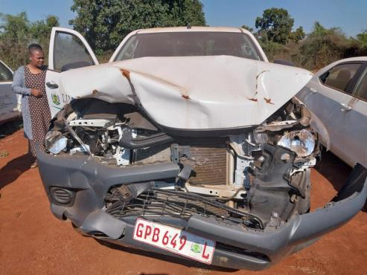



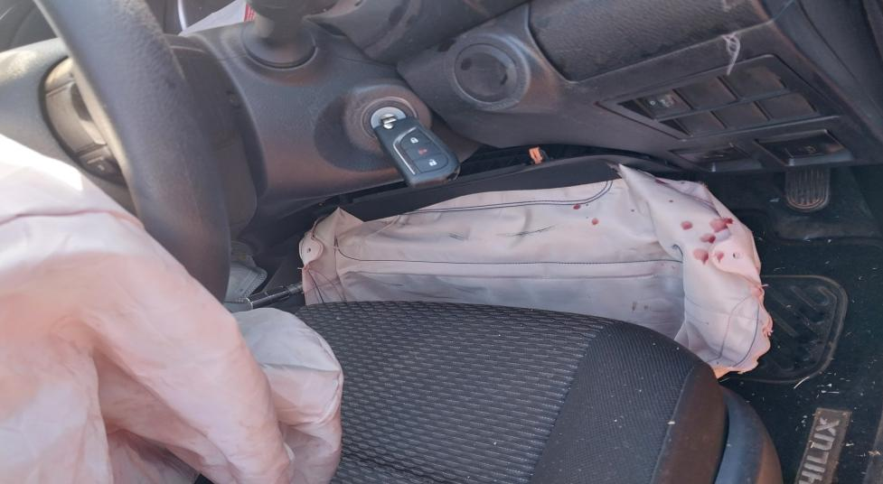

PHOTO AFTER

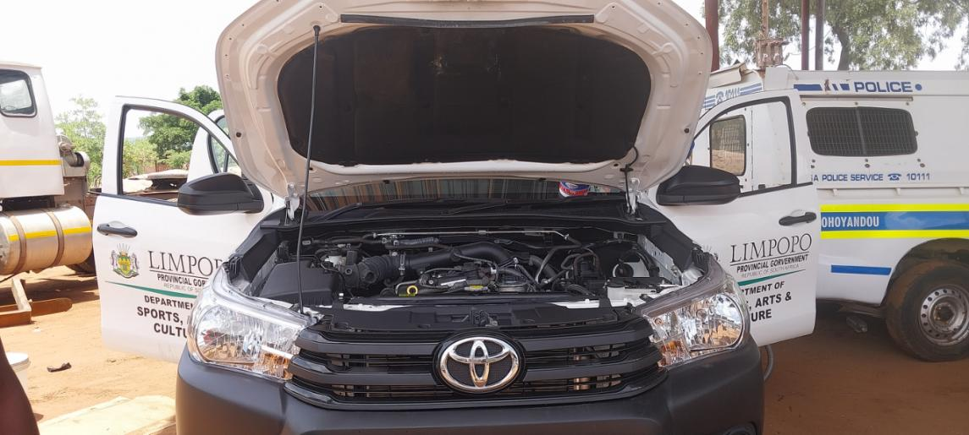

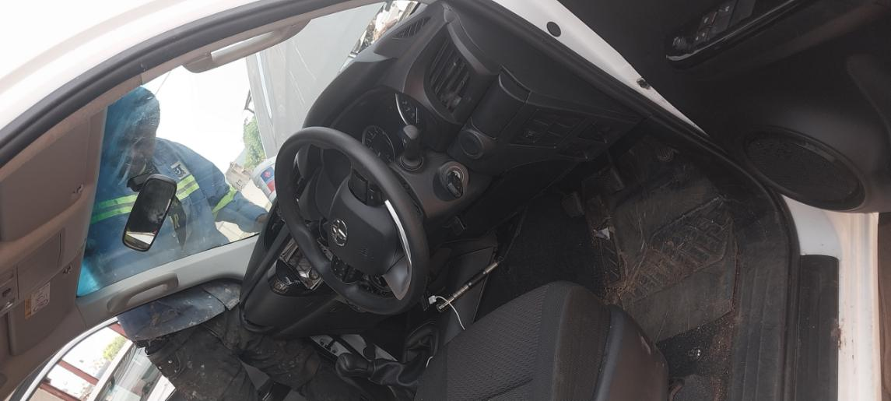

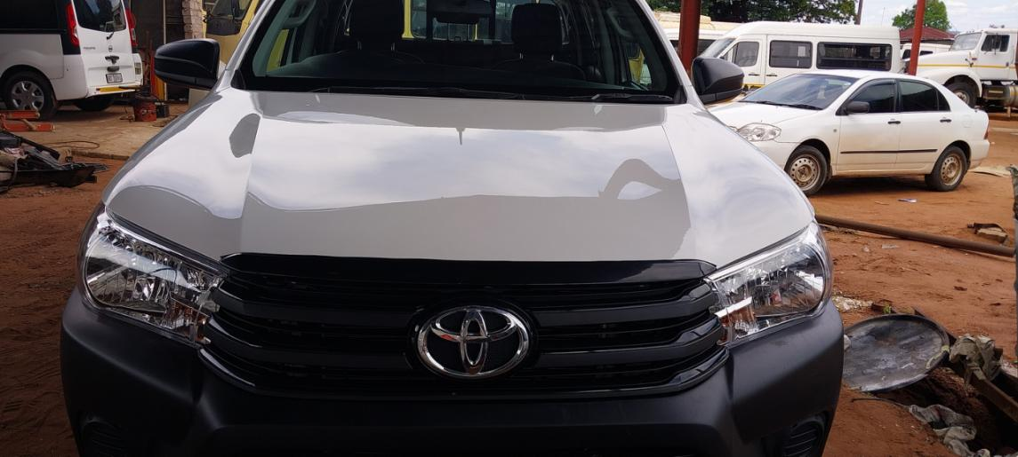

Before picture NISSAN NP200 1.6 16 V

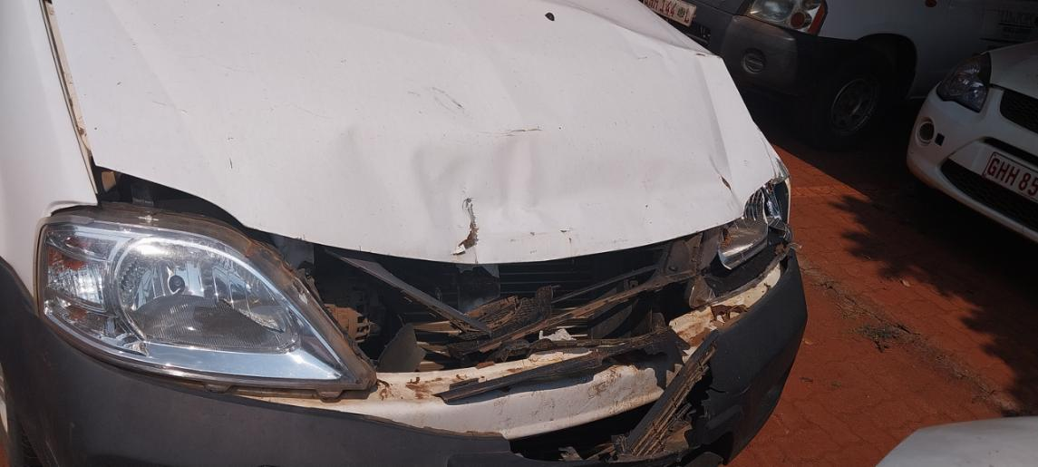

Photo after NISSAN NP200 1.6 16 V

