Logo2023.jpg

Latingoods Corporation

**66 W Flagler St. Suite 900 #8403**

**Miami, FL 33130 – USA**

**Ph: +1 (786)-785-6484**

**email:** [**crmo@latingoodscorp.com**](mailto:crmo@latingoodscorp.com)

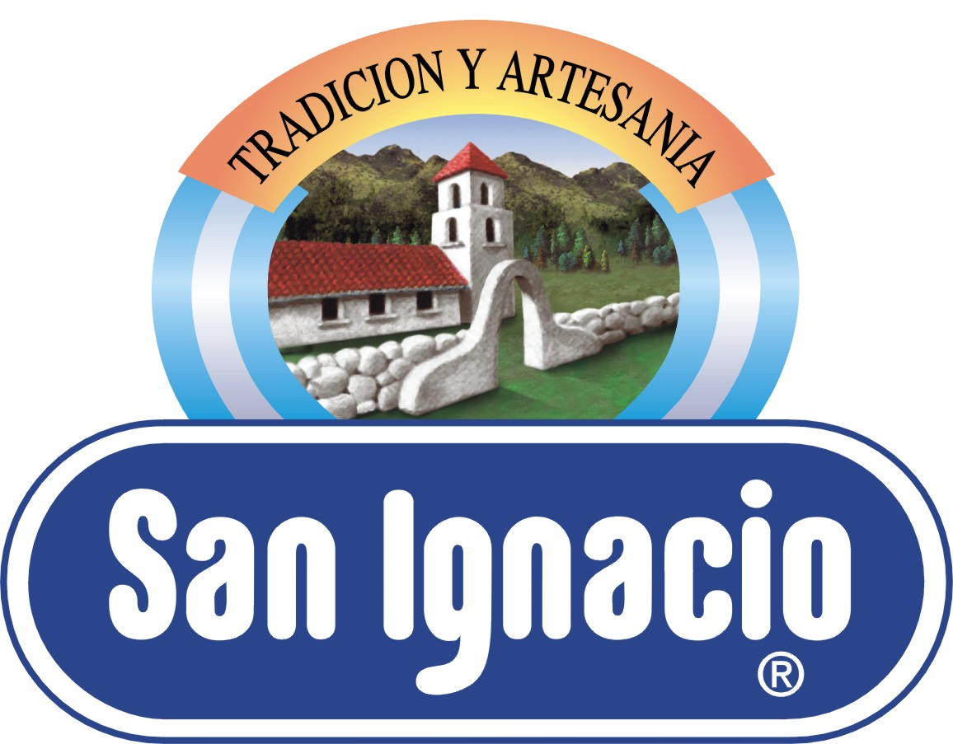

As an Ice Cream maker, you should know that “Dulce de Leche” is a fast growing flavor in America, and in a couple of years it will be a "must have" flavor.

Latingoods Corp. is proud to offer you the best “Dulce de Leche” for Ice Cream from Argentina, a country where three out of every four people choose this as their favorite flavor.

San Ignacio’s Dulce de Leche has set the quality, flavor and performance standards that every dulce de leche’s producer wants to reach.

San Ignacio is the brand used by the top ice creams factories of Argentina and other countries around the world, it is the ideal ingredient because of its incomparable taste, intense color, soft texture and harmonious aroma.

Dulce de Leche San Ignacio for Ice Cream is already available in America through our distributor’s warehouse in Miami, FL:

Pampa Group LLC

Phone: 786-301-0412 / 305-691-1099 / 305-691-1092

email: [pozzonimaria@gmail.com](mailto:pozzonimaria@gmail.com).

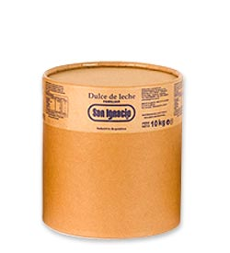

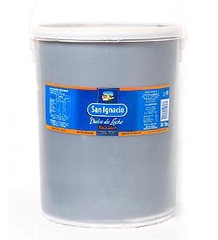

Do not miss the opportunity to contact us, we are truly looking forward to giving you all the information you may need, as well as the product’s specification sheet and the price list.

Or visit our website: [www.latingoodscorp.com](http://www.latingoodscorp.com/)  for further information.