Logo2023.jpg

Latingoods Corporation

**66 W Flagler St. Suite 900 #8403**

**Miami, FL 33130 – USA**

**Ph: +1 (786)-785-6484**

**email:** [**crmo@latingoodscorp.com**](mailto:crmo@latingoodscorp.com)

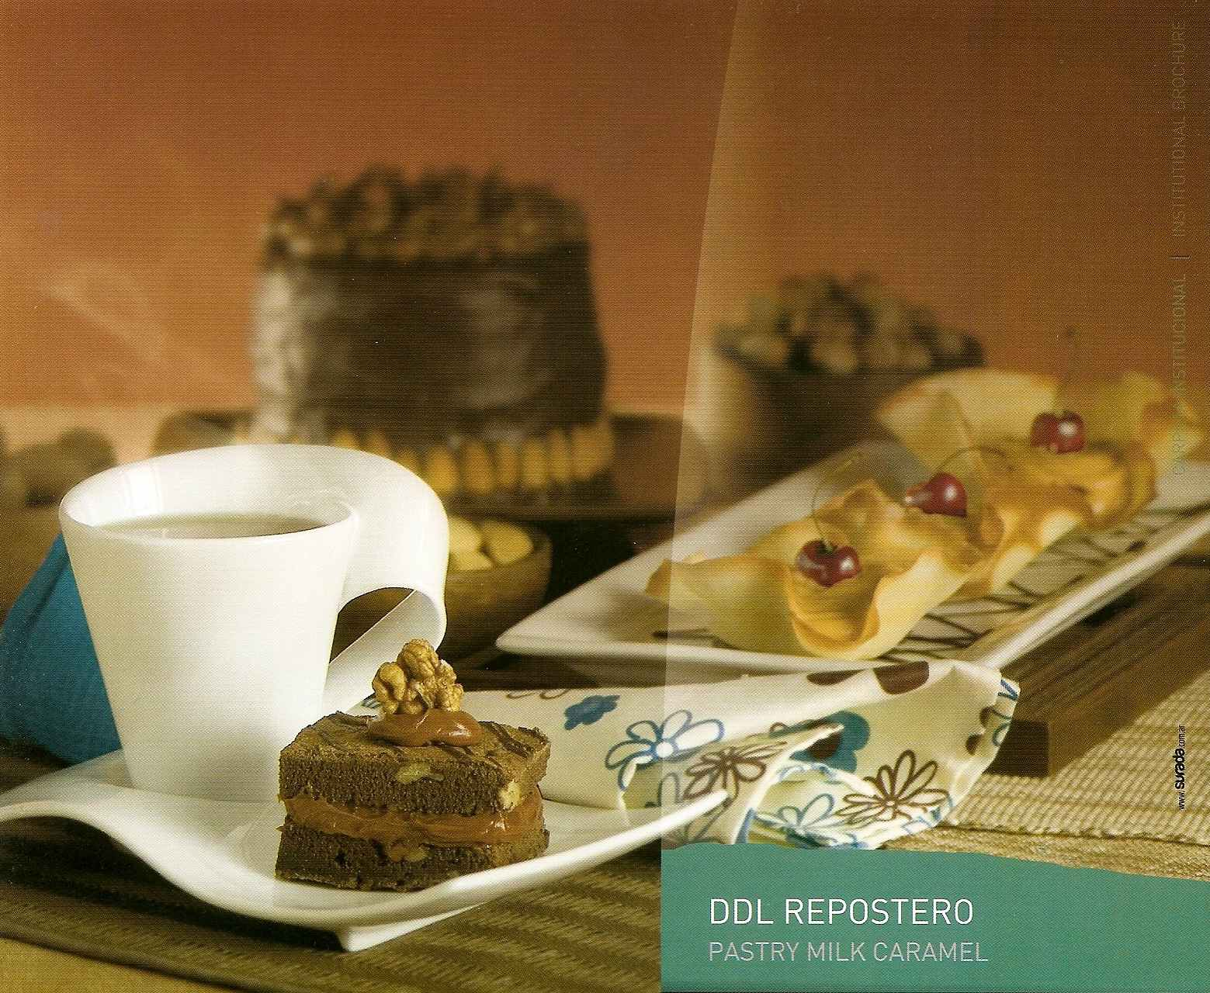

We want to introduce you to **The Dulce de leche,** better known as milk caramel spread, the ideal companion in family breakfasts and afternoon snacks. As well as a great ingredient in both homemade and industrial preparations of cakes, crepes, waffles, desserts, chocolates, biscuits, puddings, ice creams and an unlimited .variety of recipes. Not to mention its exquisite taste as a topping, filling, icing or frosting for “alfajores”, candies, cookies, cupcakes, pies, in addition to the already mentioned uses.

Dulce de leche is a confection prepared by slowly heating sweetened milk to create a product that derives its taste from the caramelization of the product, changing flavor and color. Literally translated, it means "candy of milk", without the shadow of a doubt, “Dulce de Leche” has a unique and incomparable taste, intense color, soft texture and harmonious aroma which makes it the strongest product in the sweet market.

Dulce de Leche Colonial for pastry, from Granja Pocha is already available in America through our distributor’s warehouse in Miami, FL:

Pampa Group LLC

Phone: 786-301-0412 / 305-691-1099 / 05691-1092

email: [pozzonimaria@gmail.com](mailto:pozzonimaria@gmail.com).





Do not miss the opportunity to contact us, we are truly looking forward to giving you all the information you may need, as well as the product’s specification sheet and the price list.

Or visit our website: [www.latingoodscorp.com](http://www.latingoodscorp.com/)  for further information.