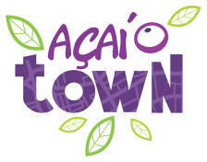

Dear Sirs,

LETTER OF INTRODUCTION

Allow me to introduce to you Açaí Town company is a registered business that works producing products derived from the açaí fuit, thou, mainly the pulp, which ir considered to be an excellent natural energizer whit antioxidant and revitalizing proprierties.

Açaí Town company ir leading supplier, it supplies to over 100 clients from the small convenience store to large wholesalers, and rising exporter of açaí on the global market, in a way it can put to practice its philosophy os close relationship between the industry and the clients. Açaí Town is the commercial identity assumed to brand itself on a global market.

Please, feel free to contact our firm to learn more about the services and to draw a contract, in case you’re interested in doing business with us.

I took the liberty to include a list of their products, technical information and prices below.

Furthermore, contact me for closing negotiations, if disered.

Your truly,

|  |
| --- |
| **COMMERCIAL PRESENTATION** |

**About US**

Nice to meet you. We are the Açaí Town, a network specialized in acai berry creams, settled since 2014. The traditional company of Tatui, in the State of Sao Paulo, ended up growing a lot and conquering new horizons.

The tasty Açaí Town products began to attract the attention of investors all over Brazil and abroad. But we have been keeping the same excellence of our service in the last few years.

More and more people are searching, questioning, and connecting with each other, sharing experiences. That is why we have reached an audience that wants a healthy lifestyle without giving up the pleasures of life.

With a very high nutritional value, Açaí Town products win this new audience. We also draw attention to our interactive, innovative and transparent relationship with people.

**Acai berry**

Considered a pearl of the Amazon, acai berry is a small, round and purple fruit, which is grouped in pendulous bunches. It has a large lump and a lack of pulp. Acai berry palm tree has large, dark green strip-shaped leaves that can be up to 2 meters (6.5 feet) long.

**Benefits**

Acai berry (Euterpe Oleracea) is a functional food whose pulp is high in energy value since because it contains large amounts of lipids with omega 6 and 9, carbohydrates, fibers, vitamin E, proteins, minerals (Mn, Fe, Zn, Cu, Cr) and vast quantities of antioxidants, anthocyanins, proanthocyanidin and other flavonoids. The components of acai berry seem to have beneficial effects, as an anti-inflammatory, for immunological profile, and to fight dyslipidemia, type 2 diabetes, metabolic syndrome, cancer and prevent aging.

**Intake**

The daily consumption of 100g of acai berry is enough to fight free radicals in an adult person. Our acai cream combines perfectly beaten with juices, accompanied with fruit, ice cream, mousses and whatever your imagination allows.

Why is the consumption of acai berry recommended?

Acai berry is on the list of fruits with a higher concentration of antioxidants, substances that help body to delay or prevent the action of free radicals in the cells, avoiding permanent damage that may, over time, lead to the development of diseases such as cancer, cataracts , heart problems, diabetes and even Alzheimer’s or Parkinson’s.

|  |  |
| --- | --- |
| **Fruits** | **ORAC Index\*** |
| **Acai Berry** | **18500** |
| Prune | 5770 |
| Raisin | 2830 |
| Blueberry | 2400 |
| Blackberry | 2036 |
| Cranberry | 1750 |
| Strawberry | 1540 |
| Promegranate | 1245 |
| Raspberry | 1220 |

*\* ORAC table is is a good tool to evaluate the amount of natural antioxidants per 100 grams of food.*

|  |
| --- |
| **ACAI POWDER** |

Natural acai poder, processed through Refractance Window technology which is the most modern and innovative drying system that preserves the fruit’s propies.

**REFRACTANCE WINDOW DRYING TECNOLOGY**

Scientifically proven technology: know for being the midest methood in comercially available drying. Washington University’s studies have demonstrated that vitamin retention in this technology is higher than that freeze drying technology.

**Benefits:**

* High retention of color, flavor and aroma
* High nutrient retention
* High yield
* 100% Acai
* 100% Natural
* Lactose Free
* Gluten Free

**Shelf Life:** 24 months after production date.

**Storage:** Keep stored in dry and ventilated place, at a temperature below 26°C. Avoid exposure to direct sunlight. Do not store with products with a strong odor or animal products.

|  |
| --- |
| **ACAI CREAM** |

**ESENTATION**

The entire process of Acai Town´s manufacturing was developed focusing on people like you, who will work with the product or consume it. Whatever the way to serve, in cups, bowls, juices, vitamins or smoothies, our acai berry has achieved an irresistible flavor never experienced before.

Our work is available in a process of homogeneous mixing of the acai berry through a fast and continuous freezing to guarantee a creamy product and without crystals of ice, which are indispensable factors to facilitate the work and please consumer´s taste.

**Benefits:**

* Ready to Serve
* Easy to work in food servisse
* Is a type of sorbet
* Lactose Free
* Gluten Free

**Shelf Life:** 12 months after production date

**Storage:** Storage temperature -18°

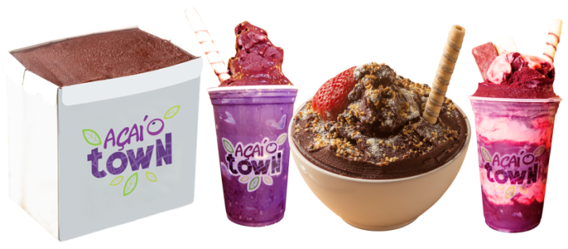

|  |
| --- |
| **TECHNICAL INFORMATION** |

|  |  |  |  |  |  |  |  |  |
| --- | --- | --- | --- | --- | --- | --- | --- | --- |
| **Technical information Powder 1 KG** | | | | | | | | |
|  | Product | | Açaí 1 KG | | Box 5 units | | | |
| NCM code | | 11.06.3000 | | 11.06.3000 | | | |
| Net weight | | 1,000 g | | 5,000 g | | | |
| Gross weight | | 1,080 g | | 5,400 g | | | |
| Freight Size | | 39cm x 13,5cm x 8cm | | 31cm x 30cm x 19cm | | | |
| Cubage | | - | | 96 boxes per palete | | | |
| Palletization/layers | | - | | 12 boxes | | | |
| Conservation | | 26°C / 78,8°F | | 26°C / 78,8°F | | | |
| **Technical information 200 mL** | | | | | | | | |
|  | Product | | | Açaí 200 ml | | | | Box 24 units |
| NCM code | | | 21.05.0090 | | | | 21.05.0090 |
| Net weight | | | 200 g | | | | 4,800 g |
| Gross weight | | | 215 g | | | | 5,160 g |
| Freight Size | | | 8cm x 8cm x 8cm | | | | 45cm x 34cm x 16cm |
| Cubage | | | - | | | | 96 boxes per palete |
| Palletization/layers | | | - | | | | 12 boxes |
| Conservation | | | - 18°C / - 0,4°F | | | | - 18°C / - 0,4°F |
| Serving Temperature | | | - 12°C / 10,4°F | | | | - 12°C / 10,4°F |
| **Technical information 2 L** | | | | | | | | |
|  | | Product | | Açaí 2 L | | Box 4 units | | |
| NCM code | | 21.05.0090 | | 21.05.0090 | | |
| Net weight | | 1,800 g | | 7,200 g | | |
| Gross weight | | 1,840 g | | 7,560 g | | |
| Freight Size | | 18cm x 14cm x 12cm | | 39cm x 28cm x 13cm | | |
| Cubage | | - | | 150 boxes per palete | | |
| Palletization/layers | | - | | 15 boxes | | |
| Conservation | | - 18°C / - 0,4°F | | - 18°C / - 0,4°F | | |
| Serving Temperature | | - 12°C / 10,4°F | | - 12°C / 10,4°F | | |
| **Technical information 10 L** | | | | | | | | |
|  | | Product | | Açaí 10 L | | | Box | |
| NCM code | | 21.05.0090 | | | 21.05.0090 | |
| Net weight | | 9,000 g | | | 9,000 g | |
| Gross weight | | 9,400 g | | | 9,400 g | |
| Freight Size | | 24,4cm x 18,0cm x 23,5cm | | | 24,4cm x 18,0cm x 23,5cm | |
| Cubage | | - | | | 120 buckets per palete | |
| Palletization/layers | | - | | | 20 boxes | |
| Conservation | | - 18°C / - 0,4°F | | | - 18°C / - 0,4°F | |
| Serving Temperature | | - 12°C / 10,4°F | | | - 12°C / 10,4°F | |

Att.

Renato Togni (Sasá)

Trade Representative

+55 (19) 98113-4445

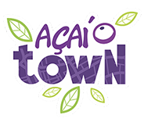

[www.acaitown.com.br](http://www.acaitown.com.br/)