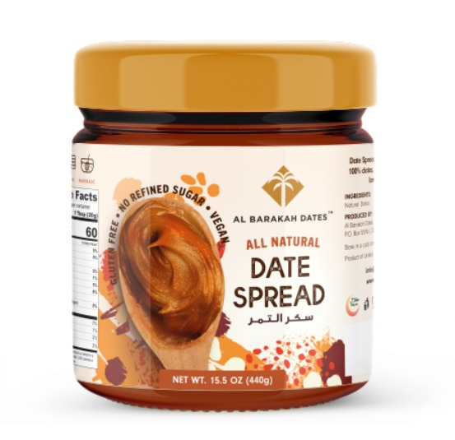

Good morning.

Keep in mind that this label has information of **440g**

And the products that you are going to send us come out with the **450g** label. Tks