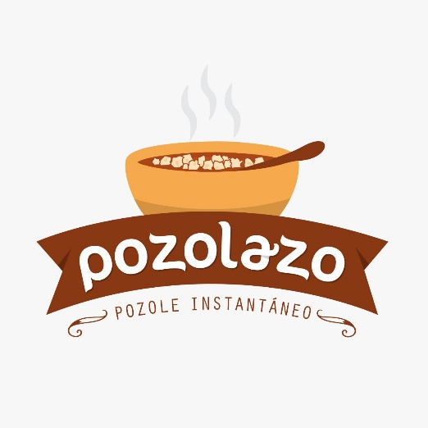

Pozolazo is elaborated with top choice quality ingredients, each of them has been selected complying with the strictest quality controls, making it a nutritious and natural food.

* Contains **20 gr of protein** above the current instantaneous or canned foods in the market.
* **GMO** free
* Without artificial flavors or colorings.
* **Ingredients**: Maze, dehydrated pork broth, dehydrated pork meat, mixture of hot peppers

(guajillo, ancho), salt, dehydrated onion, garlic powder, lemon, spices.

**Microbiological Analysis**

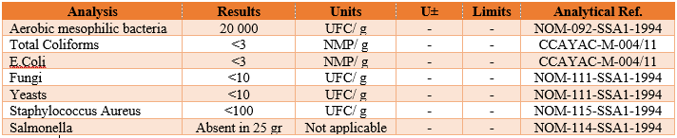

 **Nutrition Facts Lay out**

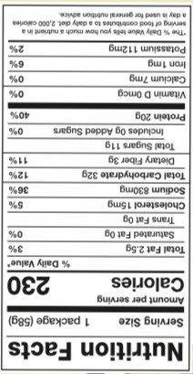MX USA

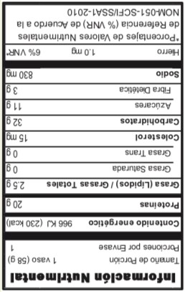

FDA / USDA Aprobada

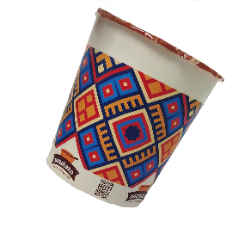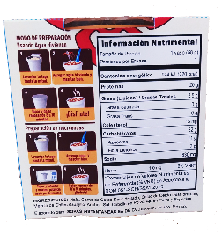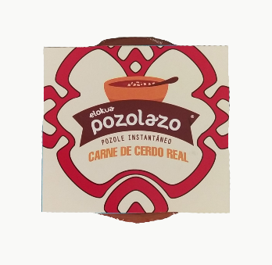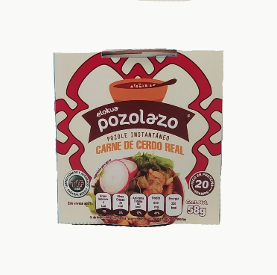**Product**

**Sopas instantáneas S.A de C.V**

**Zapopan, Jal, México. 44670**

**Tel: 3324816914**