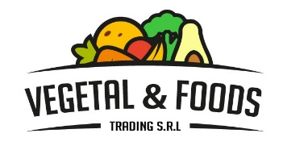

We belong to an association of fruit that is located in Piura, Peru. VEGETAL & FOODS TRADING S.R.L our company it offers the following fresh fruits: - Mangos ( Kent). - Avocados( Hass). - Organic Bananas ( Cavendish). - Lemons( Sublte). You can see them in our profile. Our products are Global GAP certified, Control Union and Fair Trade Certified ( Flo).

