**Manufacturer and Exporter of Orthopedic Implants**

**ARTHROSCOPY**

**IMPLANTS**

**Zealmax Ortho**



**#ImplantsForBetterStance** //orthoimplantsindia.com

**KNEE ARTHROSCOPY**



//orthoimplantsindia.com

**ARTHROSCOPY IMPLANTS**



Endo Button Continuous Loop

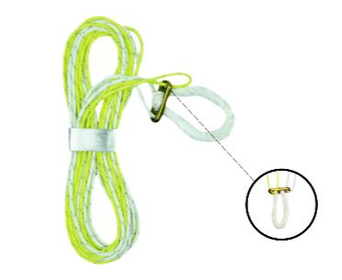

**Titanium**



**Length**

**Code**

12mm 5001.012

15mm 5001.015

20mm 5001.020

25mm 5001.025

30mm 5001.030

35mm 5001.035

40mm 5001.040



Adjustable Loop

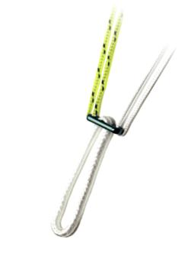

**Titanium**



**Code**

5002.001



Loop Button

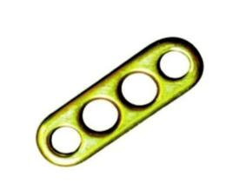

**Titanium**



**Code**

5008.001



04  **Zealmax Ortho**

//orthoimplantsindia.com

**ARTHROSCOPY IMPLANTS**



ACL Interference Screw, Cannulated

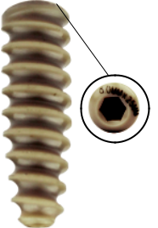

**Length**

**Peek**



**7.0mm** **8.0mm** **9.0mm** **10.0mm** **11.0mm**

20mm 5003.07.020 5003.08.020 5003.09.020 5003.10.020 5003.11.020 25mm 5003.07.025 5003.08.025 5003.09.025 5003.10.025 5003.11.025 30mm 5003.07.030 5003.08.030 5003.09.030 5003.10.030 5003.11.030 35mm 5003.07.035 5003.08.035 5003.09.035 5003.10.035 5003.11.035



ACL Interference Screw, Cannulated

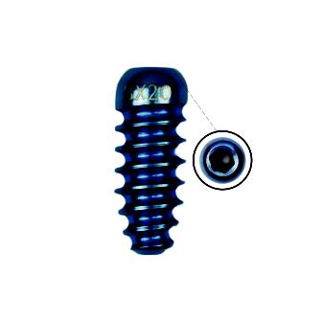

**Length**

**Titanium**



**7.0mm** **8.0mm** **9.0mm** **10.0mm** **11.0mm**

20mm 5004.07.020 5004.08.020 5004.09.020 5004.10.020 5004.11.020 25mm 5004.07.025 5004.08.025 5004.09.025 5004.10.025 5004.11.025 30mm 5004.07.030 5004.08.030 5004.09.030 5004.10.030 5004.11.030 35mm 5004.07.035 5004.08.035 5004.09.035 5004.10.035 5004.11.035

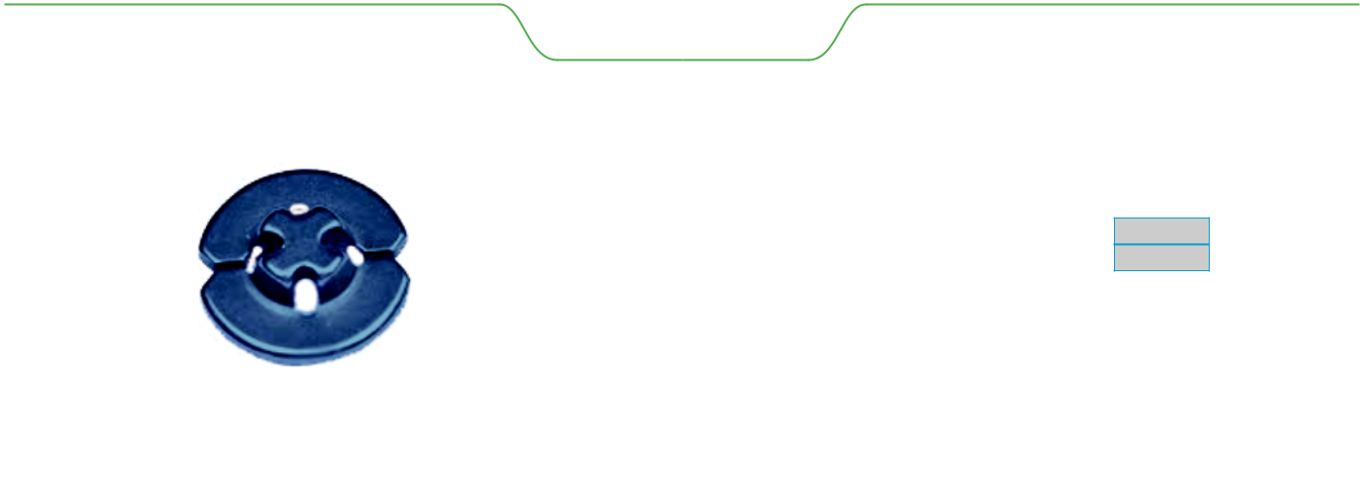

Loop Washer

**Titanium**

**Code**

5005.001



|  |  |  |  |
| --- | --- | --- | --- |
| **Zealmax Ortho** |  | 05 |  |
|  |  |

//orthoimplantsindia.com

**ARTHROSCOPY IMPLANTS**



Spiked Ligament Staple

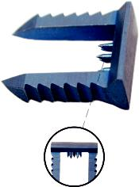

**Titanium**



**Length**

**Code**

Small 5012.S

Medium 5012.M

Large 5012.L



Tibial Post Fixation Screw 6.5mm

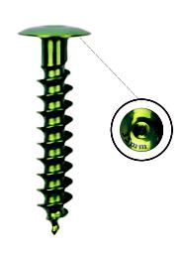

**Titanium**



**Length**

**Code**

20mm 5006.020

25mm 5006.025

30mm 5006.030

35mm 5006.035

40mm 5006.040



Tibial Suture Disk

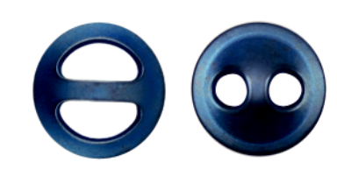

**Titanium**



**Code**

5007.D

5007.R



06  **Zealmax Ortho**

//orthoimplantsindia.com

**ARTHROSCOPY IMPLANTS**



Spiked Washer

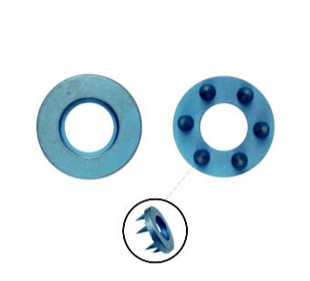

**Titanium**



**Length**

**Code**

4.0mm 5011.4.0

6.5mm 5011.6.5



4.0mm Low Profile Cancellous Screw

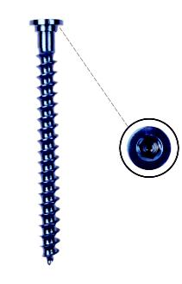

**Titanium**



**Length**

**Code**

25mm 5009.025

30mm 5009.030

35mm 5009.035

40mm 5009.040

45mm 5009.045

50mm 5009.050

55mm 5009.055

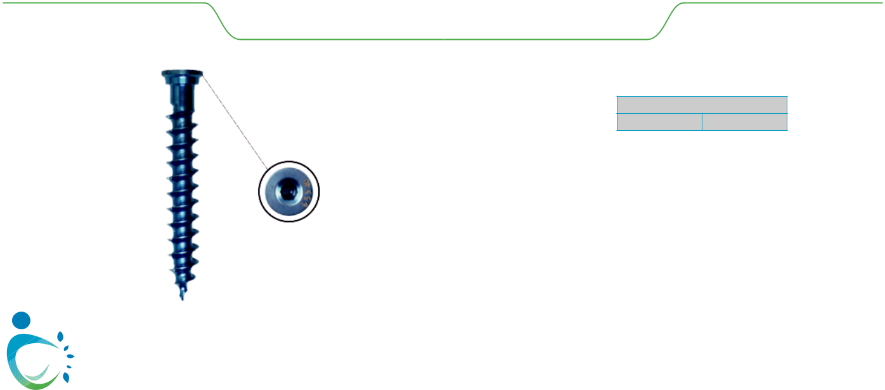

6.5mm Low Profile Cancellous Screw

**Titanium**

**Length**

**Code**

25mm 5010.025

30mm 5010.030

35mm 5010.035

40mm 5010.040

45mm 5010.045

50mm 5010.050

55mm 5010.055

|  |  |  |  |
| --- | --- | --- | --- |
| **Zealmax Ortho** |  | 07 |  |
|  |  |

**SHOULDER ARTHROSCOPY**



//orthoimplantsindia.com

**ARTHROSCOPY IMPLANTS**



Suture Anchor 2.4mm

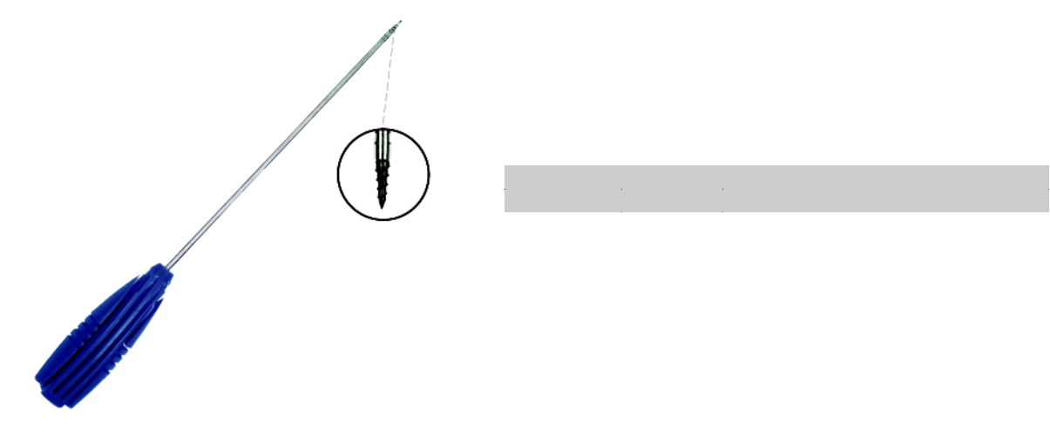

|  |  |  |
| --- | --- | --- |
|  |  | **Titanium** |
| **Length** | **Code** | **Descripon** |
| 2.4mm | 5014.12.4 | Loaded with One Pc Refiber |
| 2.4mm | 5014.52.4 | Loaded With One Pc Refiber with Needle |

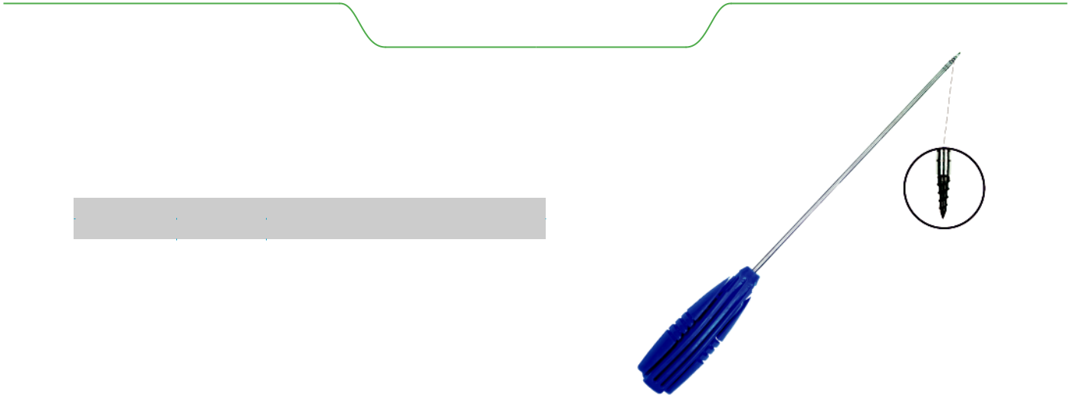

Suture Anchor 2.8mm

|  |  |  |
| --- | --- | --- |
|  |  | **Titanium** |
| **Length** | **Code** | **Descripon** |
| 2.8mm | 5013.12.8 | Loaded with One Pc Refiber |
| 2.8mm | 5013.52.8 | Loaded With One Pc Refiber with Needle |



Suture Anchor 3.0mm

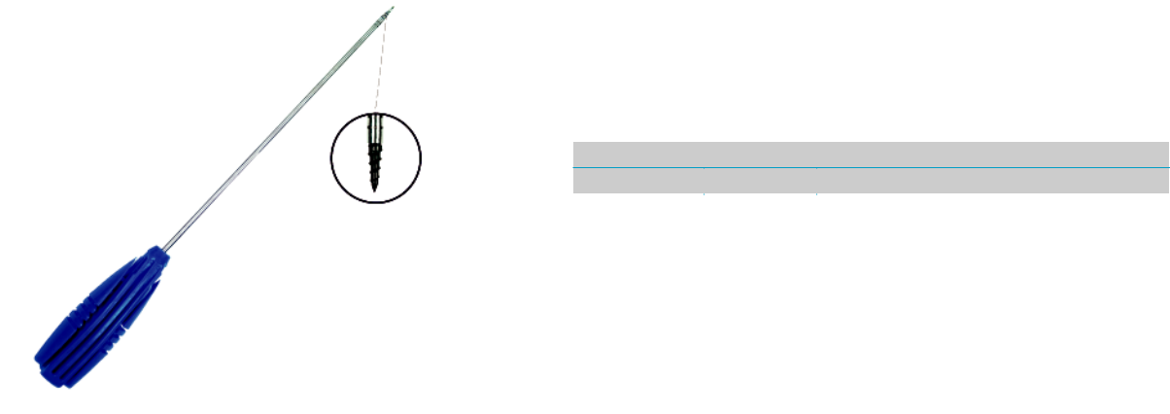

|  |  |  |
| --- | --- | --- |
|  |  | **Titanium** |
| **Length** | **Code** | **Descripon** |
| 3.0mm | 5015.13.0 | Loaded with One Pc Refiber |
| 3.0mm | 5015.53.0 | Loaded With One Pc Refiber with Needle |



010  **Zealmax Ortho**

//orthoimplantsindia.com

**ARTHROSCOPY IMPLANTS**



Suture Anchor 3.5mm

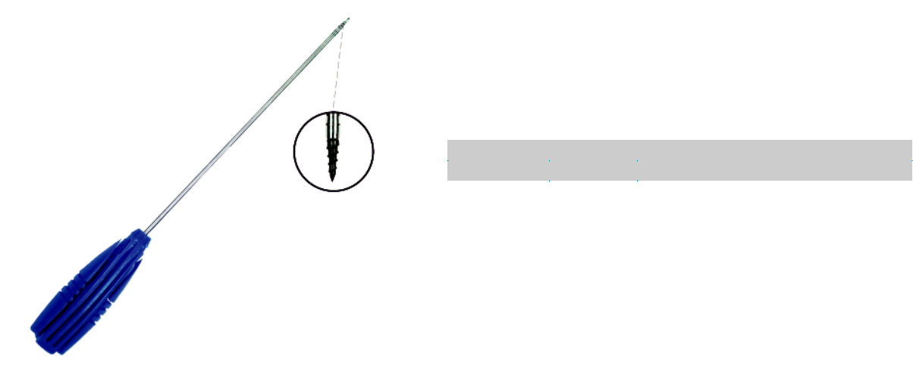

|  |  |  |
| --- | --- | --- |
|  |  | **Titanium** |
| **Length** | **Code** | **Descripon** |
| 3.5mm | 5013.13.5 | Loaded with One Pc Refiber |
| 3.5mm | 5013.53.5 | Loaded with One Pc Refiber with Needle |

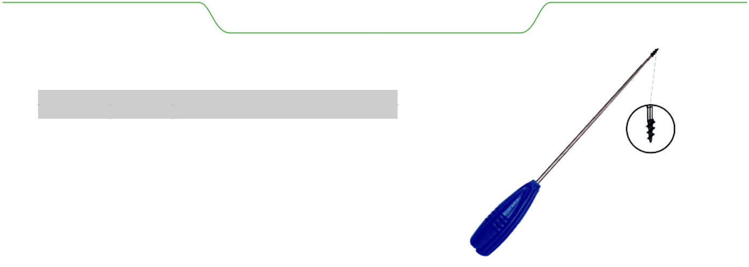

Suture Anchor 5.0mm / 6.5mm

|  |  |  |
| --- | --- | --- |
|  |  | **Titanium** |
| **Length** | **Code** | **Descripon** |
| 5.0mm | 5021.25.0 | Loaded with Two Pc Refiber #2 |
| 5.0mm | 5021.35.0 | Loaded with Three Pc Refiber #2 |
| 5.0mm | 5021.55.0 | Loaded with Two Pc Refiber #2 with Needle |
| 6.5mm | 5021.26.5 | Loaded with Two Pc Refiber #2 |
| 6.5mm | 5021.36.5 | Loaded with Three Pc Refiber #2 |
| 6.5mm | 5021.56.5 | Loaded With Two Pc Refiber #2 with Needle |

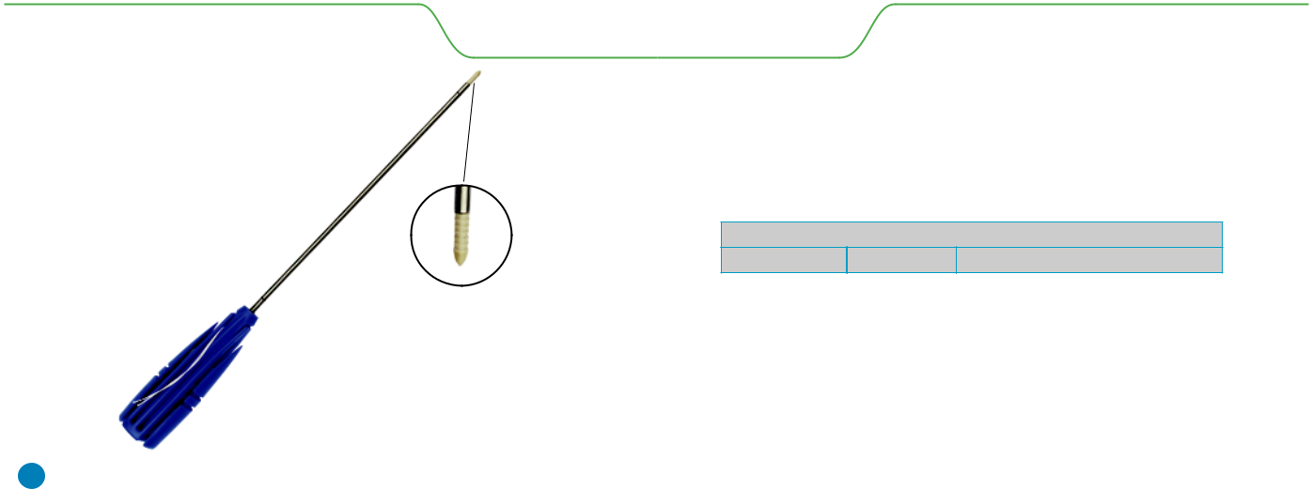

Suture Anchor Peek

**Peek**

**Length**

**Code**

**Descripon**

|  |  |  |
| --- | --- | --- |
| 2.8mm | 5017.12.8 | Loaded with One Refiber pc |
| 3.0mm | 5017.23.0 | Loaded with Two Refiber pc |
| 3.5mm | 5017.23.5 | Loaded with Two Refiber pc |



|  |  |  |  |
| --- | --- | --- | --- |
| **Zealmax Ortho** |  | 011 |  |
|  |  |

//orthoimplantsindia.com

**ARTHROSCOPY IMPLANTS**



Suture Anchor Peek 5.5mm

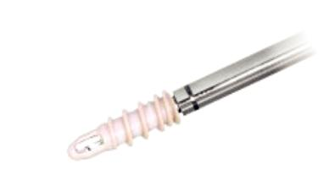

**Peek**



**Length**

**Code**

**Descripon**

|  |  |  |
| --- | --- | --- |
| 5.5mm | 5022.25.5 | Loaded with Two Pc Refiber |
| 5.5mm | 5022.35.5 | Loaded with Three Pc Refiber |



2.8mm Dual Threaded Suture Anchor

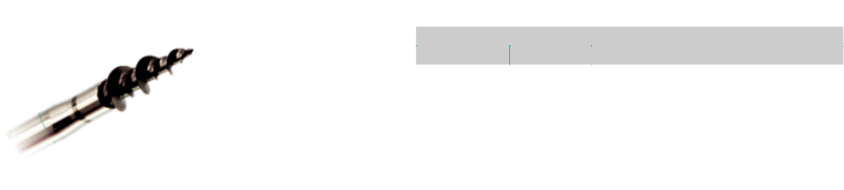

|  |  |  |
| --- | --- | --- |
|  |  | **Titanium** |
| **Diameter** | **Code** | **Descripon** |
| 2.8mm | 5016.12.8 | Loaded with One Pc Refiber |
| 2.8mm | 5016.52.8 | Loaded with One Pc Refiber with Needle |
| 3.5mm | 5016.13.5 | Loaded with One Pc Refiber |
| 3.5mm | 5016.53.5 | Loaded With One Pc Refiber with Needle |

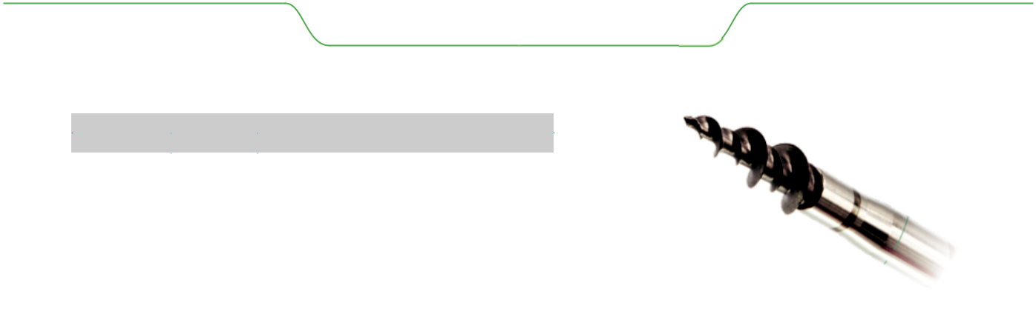

Dual Threaded Suture Anchor

|  |  |  |
| --- | --- | --- |
|  |  | **Titanium** |
| **Length** | **Code** | **Descripon** |
| 5.0mm | 5020.25.0 | Loaded with Two Pc Refiber #2 |
| 5.0mm | 5020.35.0 | Loaded with Three Pc Refiber #2 |
| 5.0mm | 5020.55.0 | Loaded with Two Pc Refiber #2 with Needle |
| 6.5mm | 5020.26. 5 | Loaded with Two Pc Refiber #2 |
| 6.5mm | 5020.56.5 | Loaded with Two Pc Refiber #2 with Needle |



012  **Zealmax Ortho**

//orthoimplantsindia.com

**ARTHROSCOPY IMPLANTS**



Suture Anchor Knotless Peek

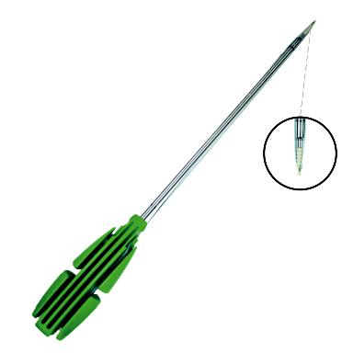

**Peek**



**Length**

**Code**

**Descripon**

|  |  |  |
| --- | --- | --- |
| 2.8mm | 5018.02.8 | Peek Tip |
| 3.0mm | 5018.03.0 | Peek Tip |
| 3.5mm | 5018.03.5 | Peek Tip |

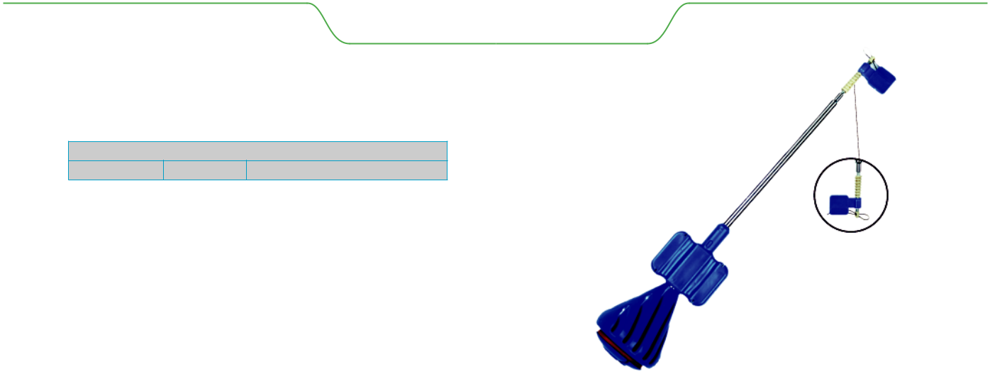

Suture Anchor Knotless

**Peek**

**Length**

**Code**

**Descripon**

|  |  |  |
| --- | --- | --- |
| 4.5mm | 5023.P4.5 | Peek Tip |
| 4.5mm | 5023.T4.5 | Titanium Tip |
| 5.0mm | 5023.P5.0 | Peek Tip |
| 5.0mm | 5023.T5.0 | Titanium Tip |
| 5.5mm | 5023.P5.5 | Peek Tip |
| 5.5mm | 5023.T5.5 | Titanium Tip |



Disposable Cannula

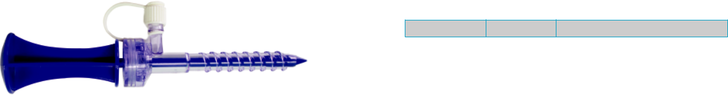

**Length**

**Code**

**Descripon**

|  |  |  |
| --- | --- | --- |
| 8.25x70mm | 5026.001 | Disposable Cannula Trocar Point |
| 8.25x90mm | 5026.002 | Disposable Cannula Trocar Point |



|  |  |  |  |
| --- | --- | --- | --- |
| **Zealmax Ortho** |  | 013 |  |
|  |  |

//orthoimplantsindia.com

**ARTHROSCOPY IMPLANTS**



ReFiber

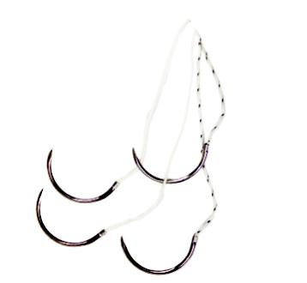

**Code**

**Titanium**



**Descripon**

5024.001 U Fiber, USP #2, with Needle(MO-6),White 36"

5024.002 U Fiber, USP #2, with Needle(MO-6),White with Black Tracer, 36"

5024.003 U Fiber, USP #5, with Needle(MO-6),White 36"

5024.004 U Fiber, USP #5, with Needle (MO-6),White with Black Tracer, 36"



Tape

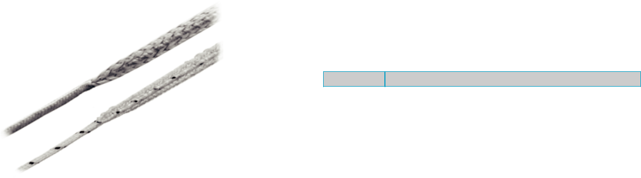

**Code**

**Descripon**

5025.001 Tape Size 2mm, White-Black, 39", Working Length 7.5"



014  **Zealmax Ortho**

//orthoimplantsindia.com

**ARTHROSCOPY INSTRUMENT SET**

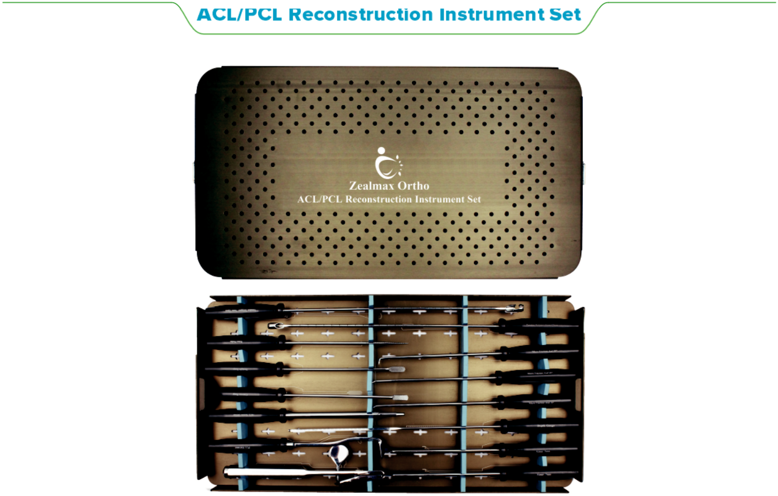

ACL/PCL Reconstruction Instrument Set

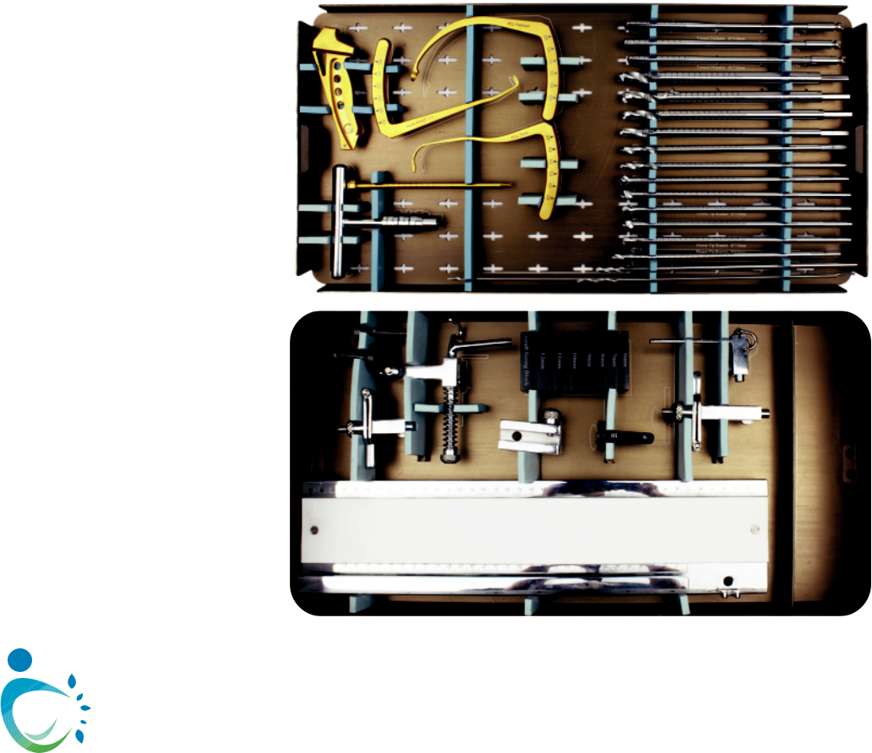

|  |  |  |  |
| --- | --- | --- | --- |
| **Zealmax Ortho** |  | 015 |  |
|  |  |

//orthoimplantsindia.com

**ARTHROSCOPY INSTRUMENT SET**



Shoulder Instrument Set

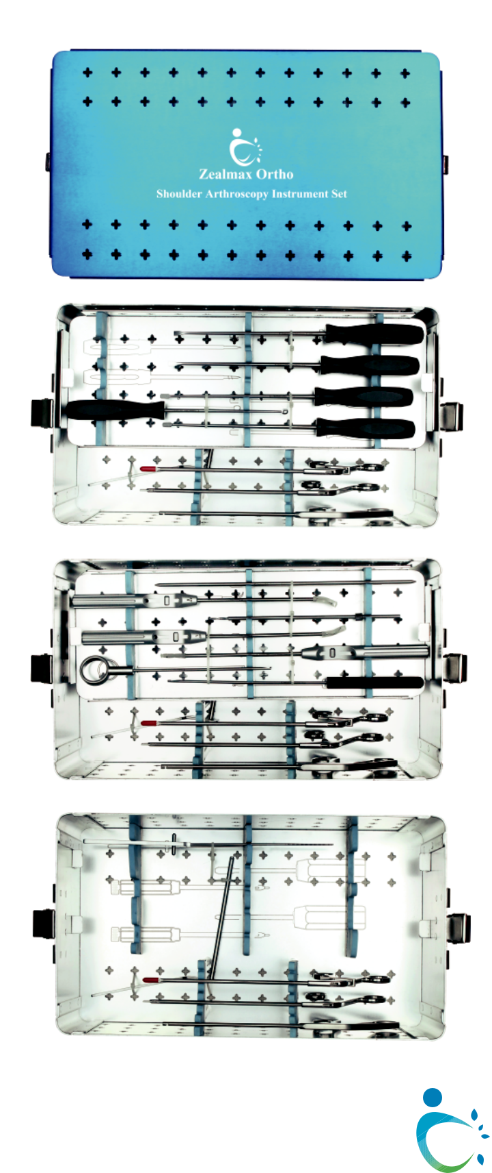

016  **Zealmax Ortho**



**ORTHOPEDIC IMPLANTS**

**Manufacturer & Exporter**

**13485**

**CERTIFIED** **REGISTERED**

**CERTIFIED** **CERTIFIED**





www.orthoimplantsindia.com

504, Indraprasth Business House, University Area,

Vijay Cross Road, Navrangpura,

Ahmedabad- 380009, Gujarat, India.

 +91-93136 15946  export@orthoimplantsindia.com