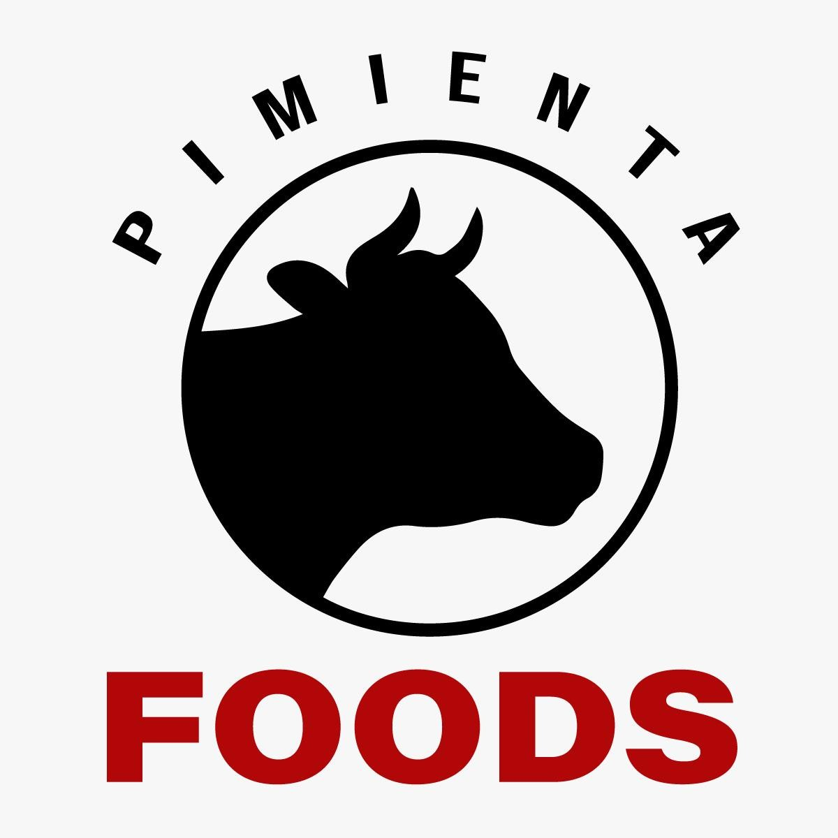

# B O V I N E M E A T / P O U L T R Y



**COMMERCIAL AGENT INTERNATIONAL QUALITY / COMPLIANCE / GOOD PRICE**

[https://www.pimientafoods.com](https://www.pimientafoods.com/)

**LUIS PIMIENTA**

# General Manager

## (+57) 304 684 9919

[manager@pimientafoods.com](mailto:manager@pimientafoods.com)

**BARRANQUILLA – COLOMBIA**

**Countries, Our Products are Certified**

1. **Angola**



1. **Saudi Arabia**
2. **Armenia**
3. **Belarus**
4. **Colombia**
5. **Curazao**
6. **Egypt**
7. **United Arab Emirates 9- Georgia**
8. **Hong Kong**
9. **Iraq**
10. **Japan**
11. **Jordan**
12. **Kazakhstan**
13. **Kyrgystan**
14. **Libya**
15. **Russia**
16. **Viet Nam**



**WHO CERTIFY OUR SUPPLIERS BEEF and POULTRY**

**Sanitary Certifications**



**Quality Certifications of Production Plants**



**Products and Production Capacity**

**A- BOVINE MEAT.**



1. **Whole Beef Without Bone**
   * Current Capacity: 400 Ton / month
   * Progressive increases: 150 Ton / month
2. **Fine Cuts Bovine Meat.**

**(We Process and Sell Compensate Beef Cuts)**

* Current Capacity: 500 Ton / month
* Progressive increases: 150 Ton / month

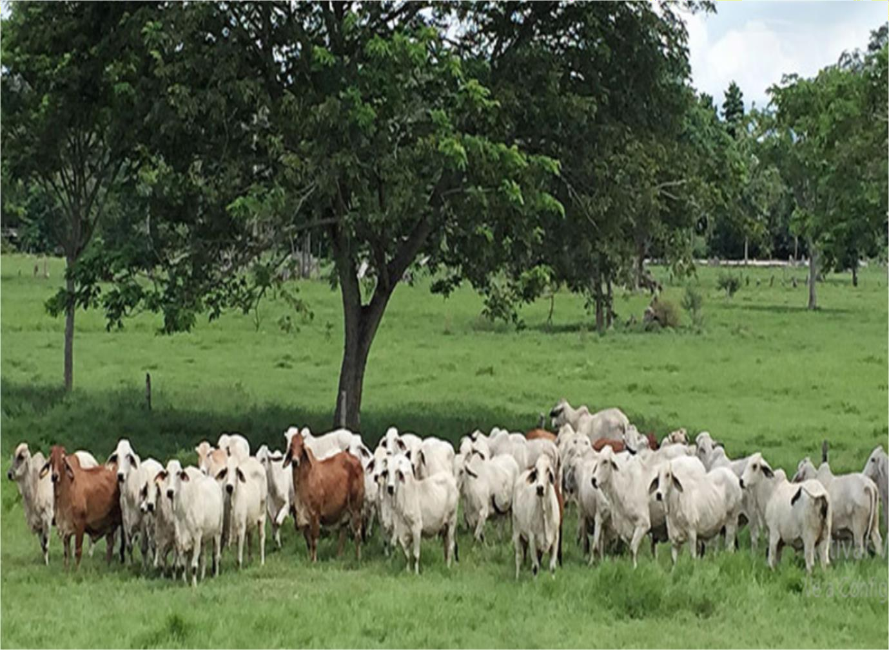

**Products and Production Capacity**

# B- POULTRY - CHICKEN.



1. **Chicken Without Entrails**
   * Current Capacity: 300 Ton / month
   * Progressive increases: 150 Ton / month
2. **Full Chicken Wing.**

* Current Capacity: 150 Ton / month
* Progressive increases: 100 Ton / month

1. **Midle Joing Wing.**
   * Current Capacity: 150 Ton / month
   * Progressive increases: 100 Ton / month
2. **Chicken Paws.**
   * Current Capacity: 150 Ton / month
   * Progressive increases: 100 Ton / month
3. **Chicken Breast.**

* Current Capacity: 200 Ton / month
* Progressive increases: 100 Ton / month