Bogotá, D.C., September 19, 2022

**Mrs.**

**María Alejandra Gil**

**Directora Comercial**

**ARAB COLOMBIAN CHAMBER OF COMMERCE** [operaciones@ccac.com](mailto:operaciones@ccac.com)

**Ciudad** ph +57 1 7957634 Mob +57 310 448 7005

Ref. **KISSCAO -** **100% CACAO - POWDER INSTANT AND SOLUBLE with its whole content of cacao butter**

**INVIMA: NSA-0010575-2021**

Dear Mrs. María Alejandra Gil

We are SUNYAGRO S.A.S., located in Bogotá - Colombia, a company dedicated to the transformation of Cacao products.

***Market, trends and niches***. There is a growing global trend towards the consumption of healthy products for the great well-being that their usual consumption represents for consumers who take care of their health, particularly in the consumption of **Cacao**, (Not cocoa, nor chocolate), to whom we present our **100% CACAO - POWDER INSTANT AND SOLUBLE with its whole content of cacao butter**.

It is suitable for everyone and for the whole family and for very special niches such as Vegetarians, Vegans, Celiacs (Gluten Free) and for a very special one of Diabetics (In Colombia we sell it in Colombian Association of Diabetics -ASODIABETES where of course it met all the requirements demanded by such prestigious entity).

Other two niches that could be reached with the same product but in bulk presentation are: a) the Horeca sector to use Cacao in their recipes and also in their menu as Hot Cacao Table and b) for CACAO processors and manufacturers of sweets, covertures, toppings and confectionery, chocolatines etc.

***A collaborative relationship***. Together we will be able to satisfy the current unsatisfied demand of those who aspire to consume 100% pure CACAO and cannot do so, because the market does not offer it, and then we could supply the need for the special niches mentioned above.

***Our Kisscao Brand, your Own Brand or Bulk*.** According with what you need, we are open to consider different alternatives according with your convenience: Example: **a)** we sell the product in our Kisscao brand presentation to be sold and distributed in your country, **b)** To produce in Colombia by our company with a brand of your own (in this case there must be a Note in the package that say: produced in Colombia by Sunyagro for …. **c)** To sell the product in bulk presentation and then you package it with your own brand in your country, **d)** Other alternatives (each alternative has its own particularities to be implemented)

***Current plant capacity and growing to satisfy your demand*.** We are able to satisfy your needs and requests. Our current installed capacity allows us to produce 8 tons/month and we will be able to easily expand up to 15 tons/month in a short time.

***Loyalty toward the brand and product.*** The experience in Colombia has been that those who taste or consume KISSCAO 100% pure CACAO for the first time, in general, probably continue to prefer it over the chocolate or cocoa products that they previously consumed, meaning that there is prompt customer loyalty, which soon it becomes in consumption and good turnover.

***Profitability.*** We offer a very good marketing margin (profitability) which will undoubtedly represent a good profit due to the combination of the following factors:

***Overall profit of the business = Profitability (margin %) X Rotation (loyalty) X Sales volume***

***Product Presentation.*** De Luxe cardboard boxes of 500 gr (17,6 Oz) and 250 gr (8.8 Oz) for the final consumer and in bulk in 10 kg boxes (packaged in two bags of 5 kg each)

The boxes can be printed in one or two selected languages ​​according to your needs (currently they are printed in Spanish and English) and we will gladly collaborate on the design aspects if needed.

***Some characteristics of our product.*** The only ingredient is CACAO and it is free of sugar or any other sweetener, preservative, flavoring, etc. is FINE FLAVOR AND AROMA COLOMBIAN CACAO, with the advantage of being powdered, also soluble and instant which is very practical for the consumer. It is considered as a SUPERFOOD, highly energetic, recommended for students and athletes who have a high energy demand.

***Use of Cacao.*** It can also be used as a topping with yogurt, ice cream, juices, fruit and/or vegetable salads, cream-type soups (asparagus, mushrooms, tomato, etc.)

***CACAO Vs Chocolate Vs Cocoa.*** KISSCAO is 100% Pure CACAO. It is not Chocolate (Chocolate is when the cacao is mixed with different ingredients like fats, lecithin, powder milk, flavors, preservatives, flours etc.) and is not Cocoa (the by side product when the Cacao Butter is extracted from Cacao; Cocoa does not have nutritional power and also is known as degreased cacao or cacao mass o cacao paste).

***Virtual training*.** We can offer virtual training to your collaborators, so that in promotion and impulse activities, they can attend and transmit to their clients the benefit of cocoa consumption and its characteristics.

***Origin of our cacao and growers*.** Cacao is grown by Producers Associations, who had suffered violence and today are re building their life and communities in the Urabá Gulf Region of Colombia in boundaries of Atlantic Sea near to on the border with Panama. There the Cacao receives both the breezes from the Atlantic Ocean and the airs and aromas that come from the Chocó jungle of the well-known Darien Gap which gives it part of its fine flavor and aroma. We support them with technology and we buy their cacao to fair prices. We also buy Cacao from growers of different regions in Colombia.

We hope soon to start a productive business relationship for mutual benefit and of course the satisfaction of your customers.

|  |
| --- |
| **Quantities:** according to your requirements |
| **Prices:** Prices will be given in other document |
| **Payment:** To be agreed |
| **Custom Position:** 1805.00.00.00 Cocoa powder without added sugar or other sweetener. |
| **Packaging:** In cardboard boxes of forty (40) units for 500 gr and cardboard boxes of forty eight (48) units for 250 gr  **Bulk**: bags of 5 kg each one. Two bags in a cardboard box for total weight of 10 kg/cardboard box |
| **Dispatch time:** To be agreed, depending on the quantities required. The estimated time includes what is related to customs procedures in Colombia. |
| **Caution:** Because cacao begins to soften at approximately 26°C and melts at 34°C, it is highly recommended to use refrigerated containers for maritime via, that maintain the temperature under 18°C |
| **INCOTERM. FOB Cartagena Colombia** |
| **INVIMA Health Notification (health authority in Colombia):** NSA-0010575-2021 |

We sell our product in Colombia in the most selected stores.

Please see some photos at the end of this document.

Attached please find:

* Health Notification of INVIMA (health authority in Colombia)
* Nutritional Table,
* Test Sensorial Test
* Data Sheet
* Photos
* Videos

Kind regards,

**HECTOR EDUARDO PATIÑO JIMENEZ**

**GENERAL MANAGER**

**SUNYAGRO S.A.S**

**Carrera 16 No 58 – 19 Sur Bogotá**

**Cel 3002159268**



***Some gourmets, health, and specialized stores where we are in Colombia:***

***ESTRENA Gourmet Store***

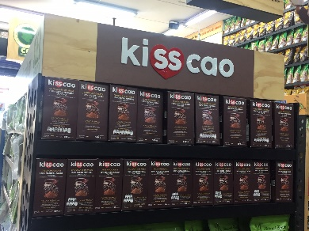 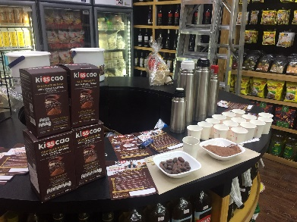 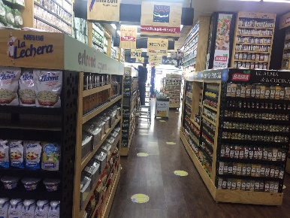

***ASODIABETES:***

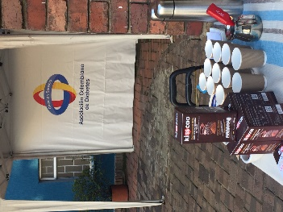

***Where we are going to be, from September 23, 2022***

***Merka Organico:***

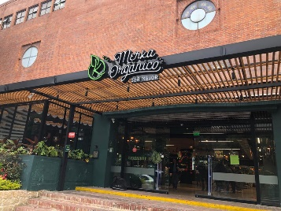 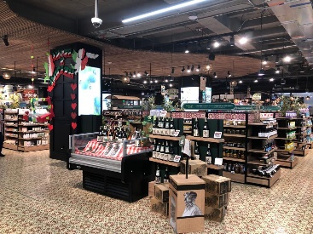 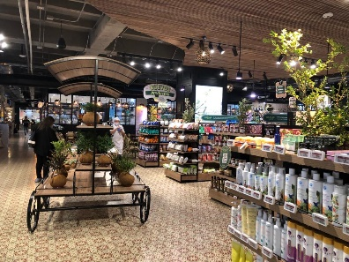 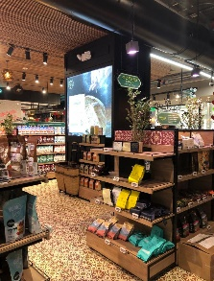

***Gastronomy Market:***

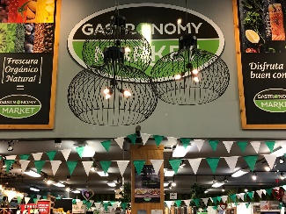 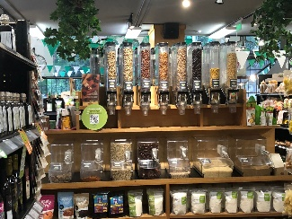 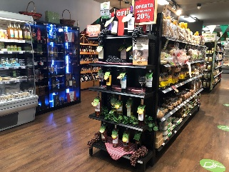 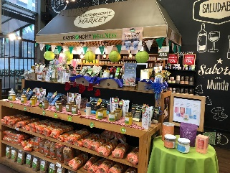

***Supporting our growers:***

 